CASE-STUDY (NUMBER - 9) – SOLUTION SUBMISSION

ON

AZURE ANALYTICS

BY

NAME –SUPRIYA BHARATHA ROLL NUMBER DXCAB1211

BATCH:DXC-262-ANALYTICS-B12-AZURE COMPANY – DXC TECHNOLOGY

TRAINING UNDER – MANIPAL PRO LEARN TRAINER NAME – MR. AJAY KUMAR DATE OF SUBMISSION – 9th JUNE 2022 TOTAL NUMBER OF QUESTIONS: 11 EMPLOYEE DOMAIN - AZURE ANALYTICS

* THE QUESTIONS:

1. Explain the steps with screenshots how to AzureSynapse analytics?

2. Explain the steps with screenshots how to SQL Pool in AzureSynapse analytics?

3. Explain the steps with screenshots how to import COVID19 dataset in AzureSynapse analytics, and run sample 500 rows & dispaly the output?

4. Explain the steps with screenshots how to input Boston Safety datasets into AzureSynapse analytics? using Notebooks ?

5. Explain the steps with screenshots how to create Spark pool in AzureSynapse analytics? ?

6. Explain the steps with screenshots how to create pipeline in AzureSynapse analytics? ?

7. Explain the steps with screenshots how to automate the pipelines in AzureSynapse analytics??

8. Explain the steps with screenshots how to Databricks ?

9. Explain the steps with screenshots how to create notebooks in Databricks ?

10. Explain the steps with screenshots how to insert data into databricks notebook & display the result?

11. Explain the steps with screenshots how to create cluster in databricks ?

1. Explain the steps with screenshots how to Azure Synapse analytics?

SOLUTION :

STEP 1: In azure portal search for synapse workspace and click on create button. And enter the details of resource group, and workspace name ,location and account name as shown .

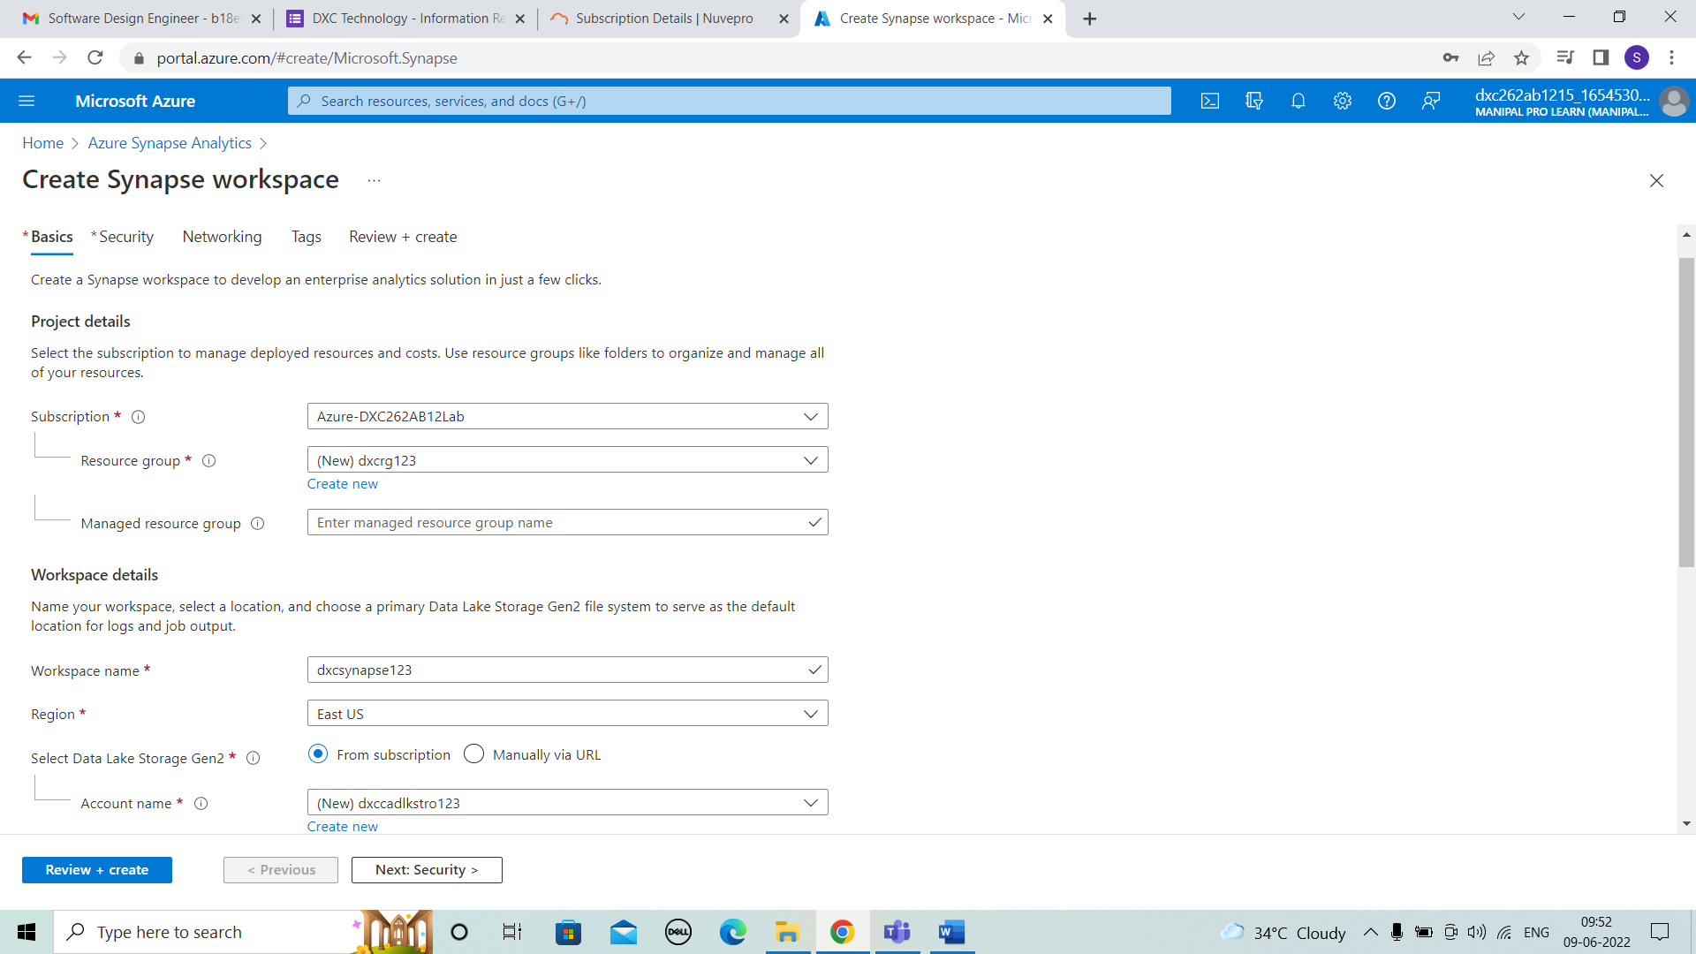



STEP 2: After clicking on next security enter the SQL server admin login and SQL password and confirm it.

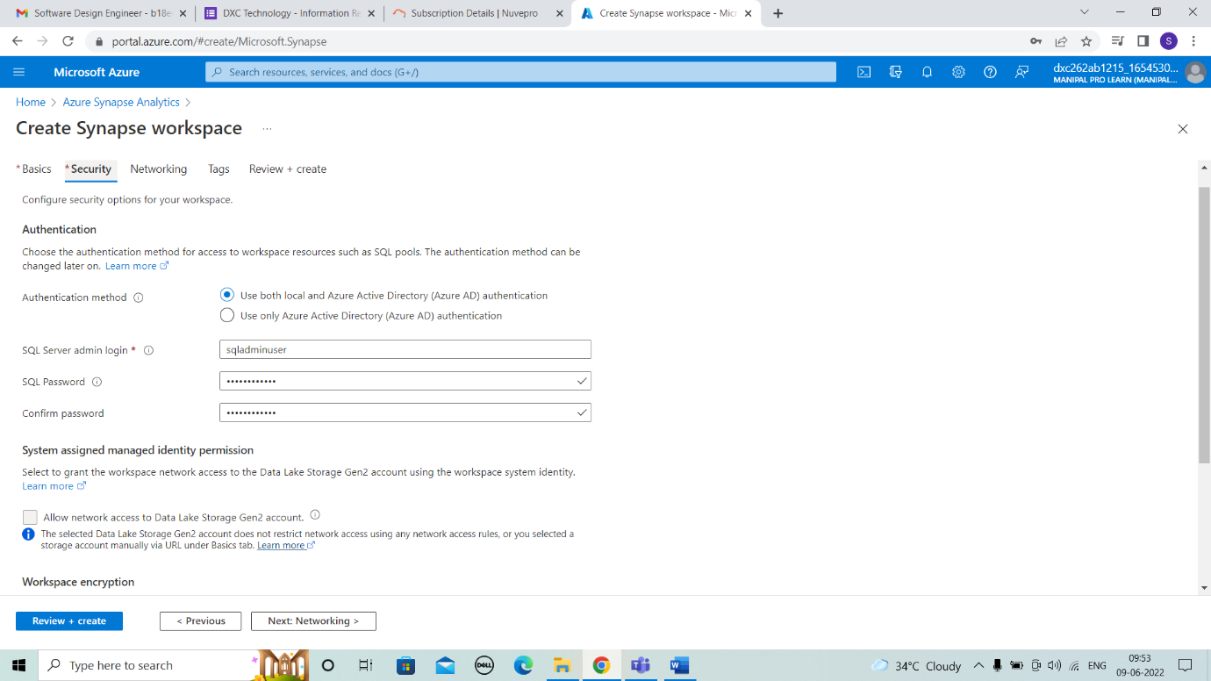



STEP 3: Next to networking and then tags.

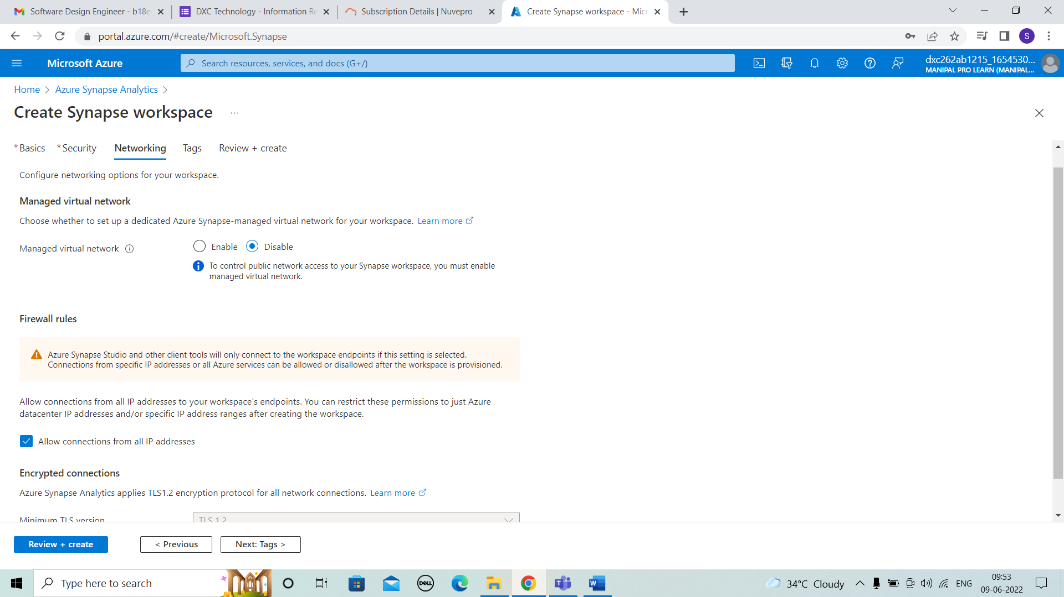



STEP 4: Here we review and then click on create button.

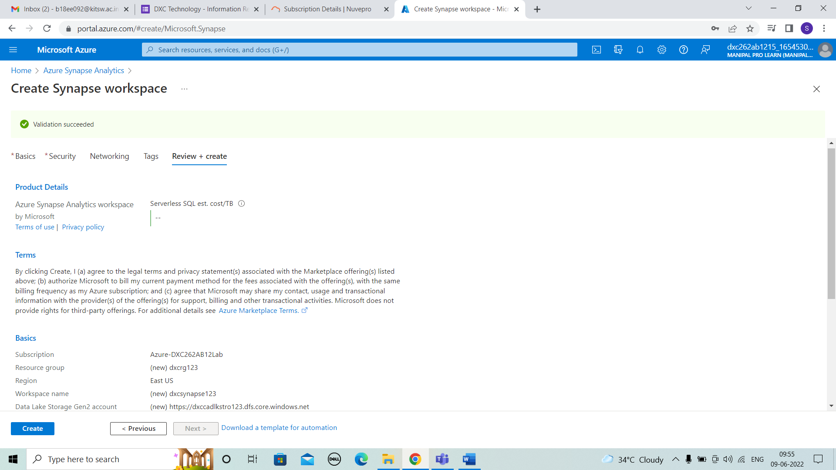



STEP 5: After clicking create button deployment will be in progress.

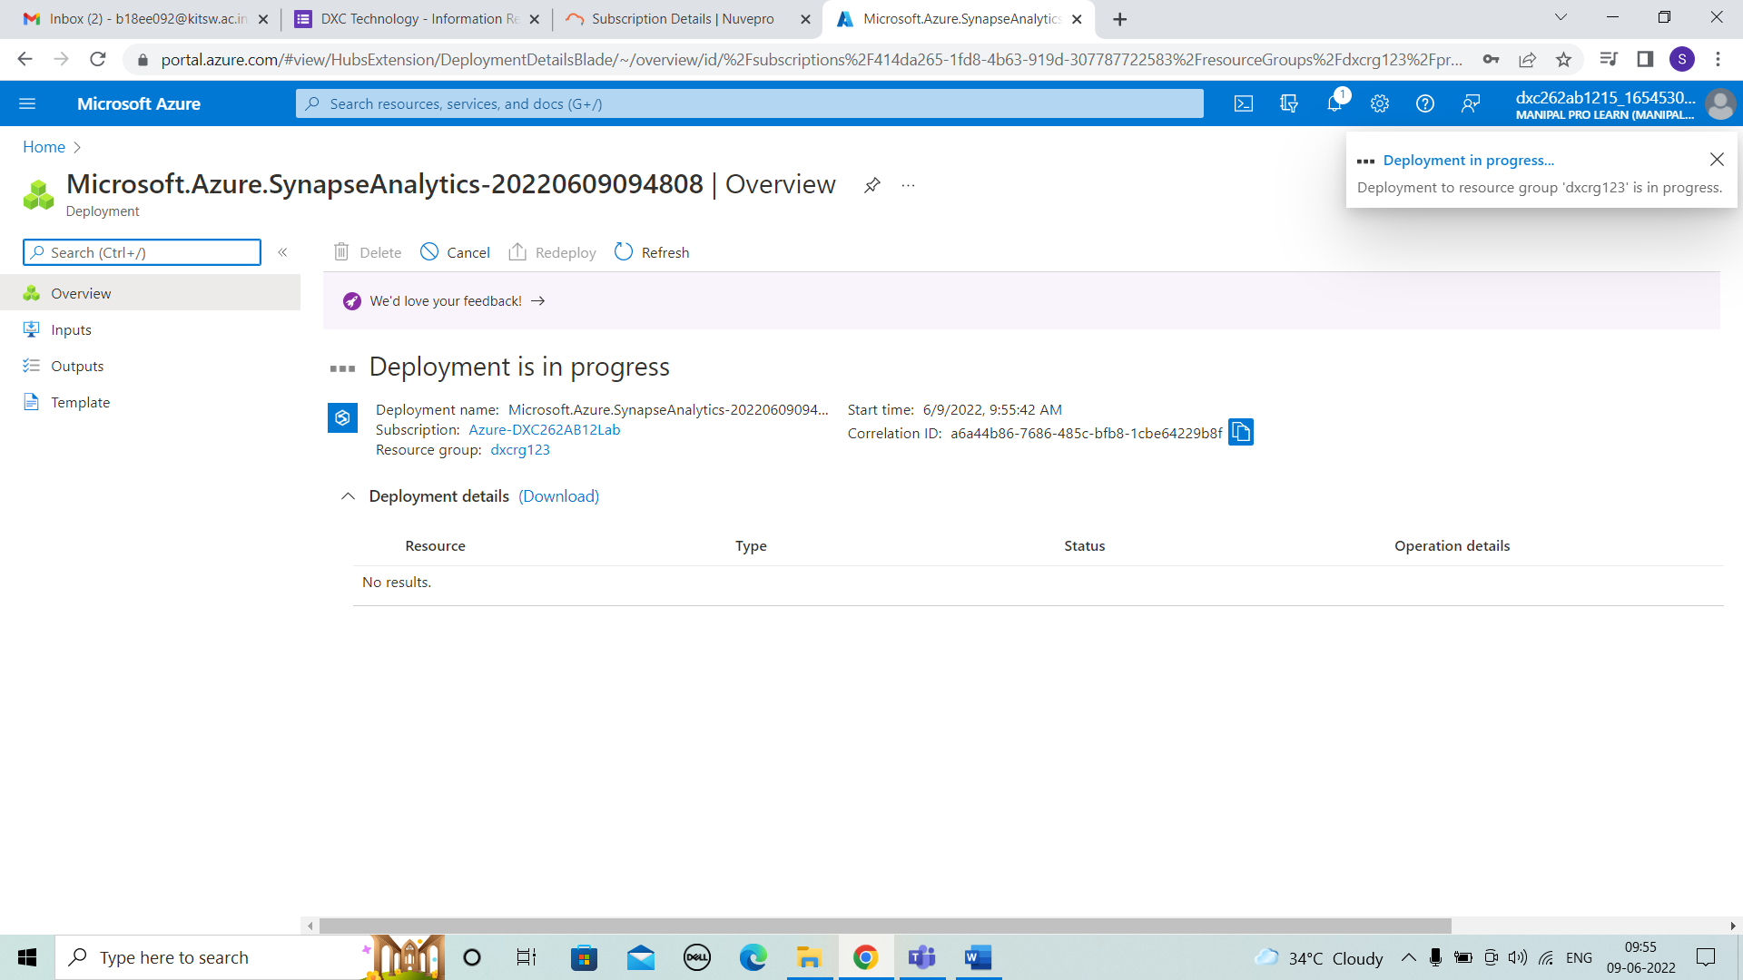



STEP 6: The deployment is completed .

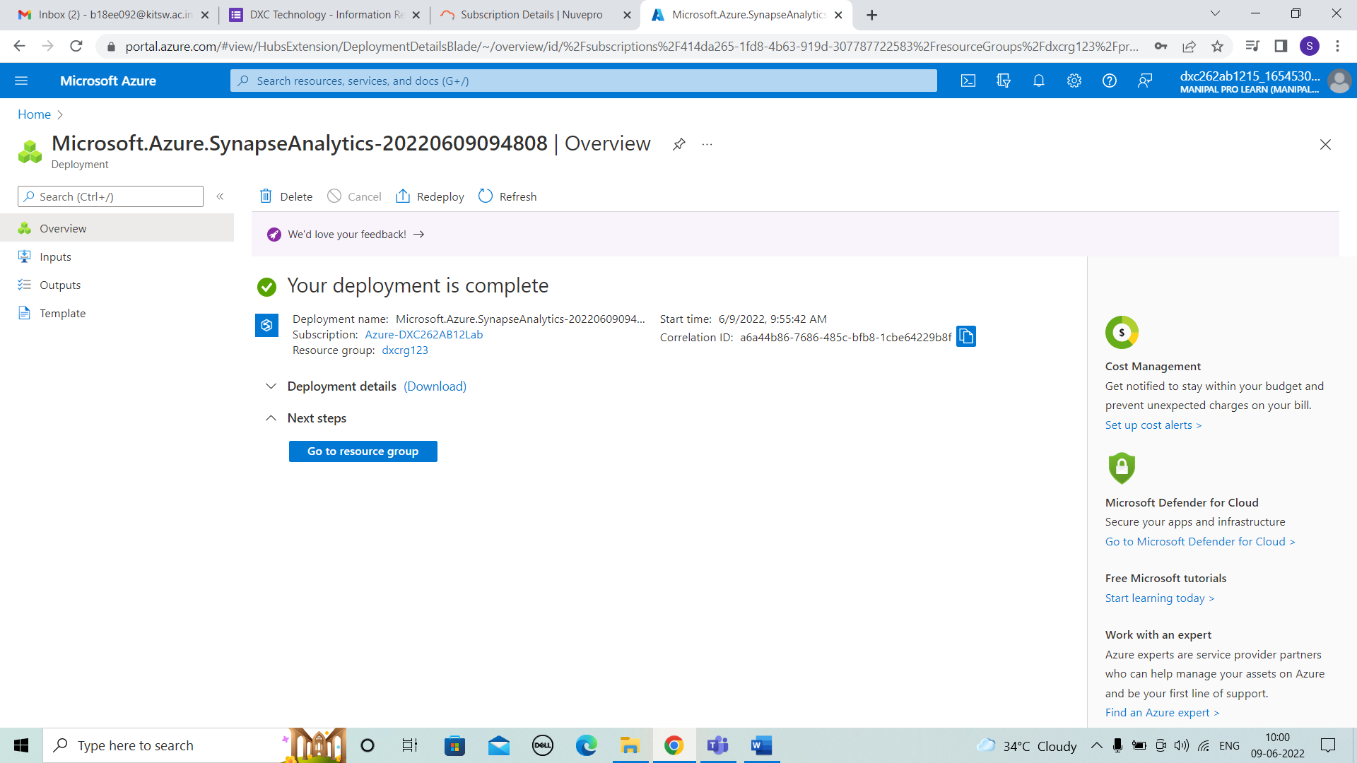



STEP 7: After deployment we can observe synapse is created and click on it.

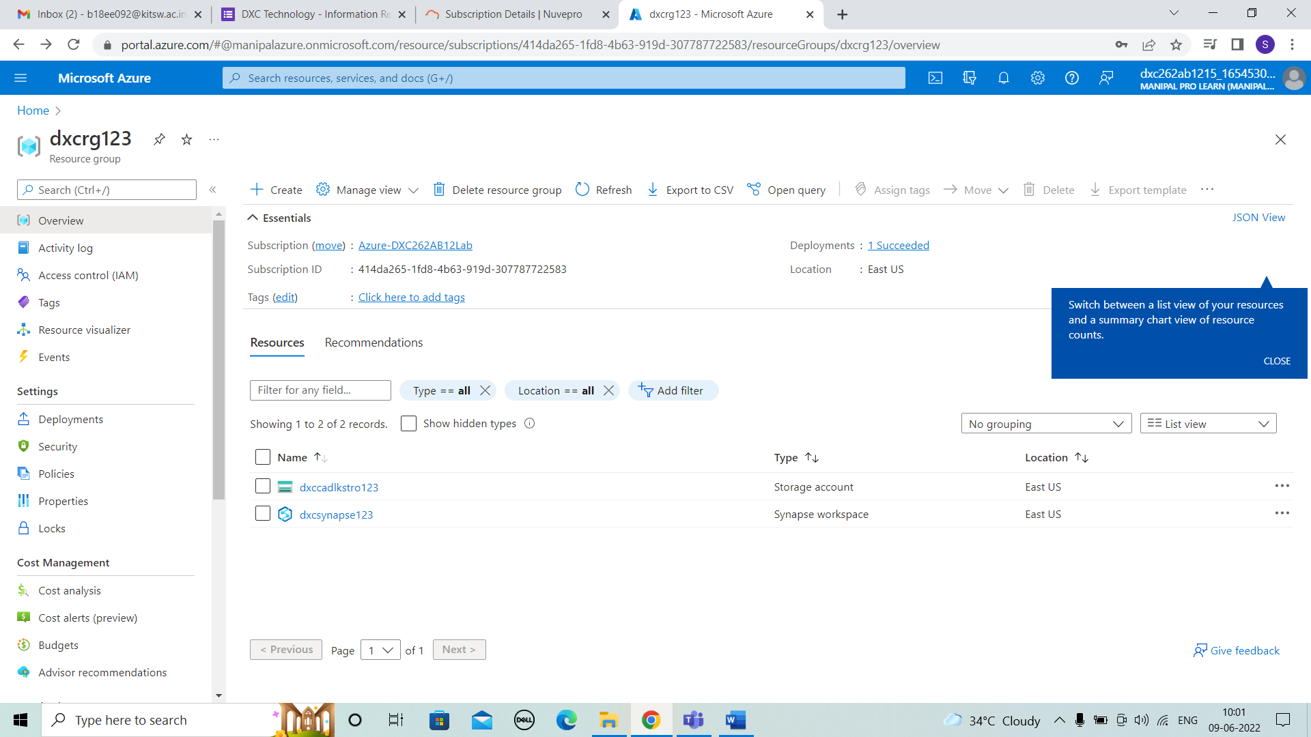



STEP 8: After opening the synapse file we can observe all the details and here we have to open synapse studio as show below.

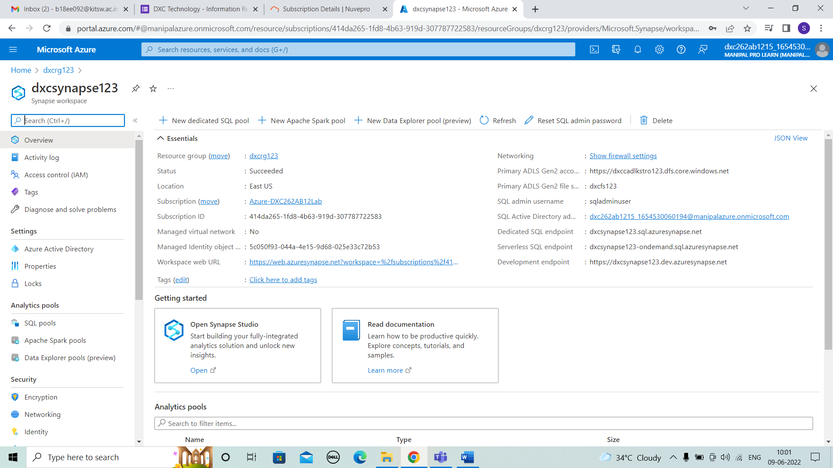



2. Explain the steps with screenshots how to SQL Pool in Azure Synapse analytics?

SOLUTION :

STEP 1 : we can choose any datasets ,here I selected boston dataset . In the same way we can browse gallery of different data sets.

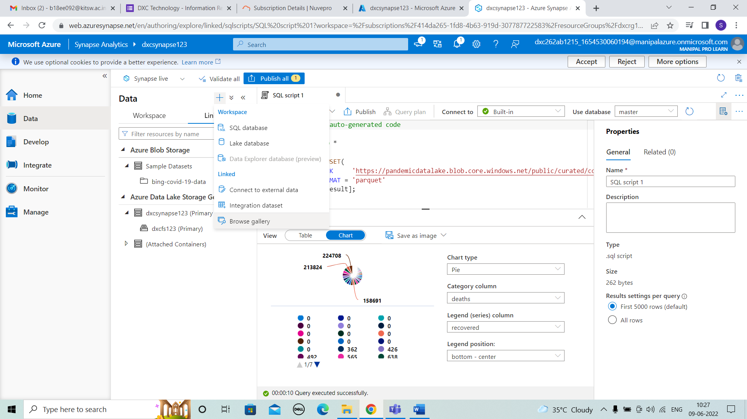



STEP 2: Now we choose boston safety data and continue.

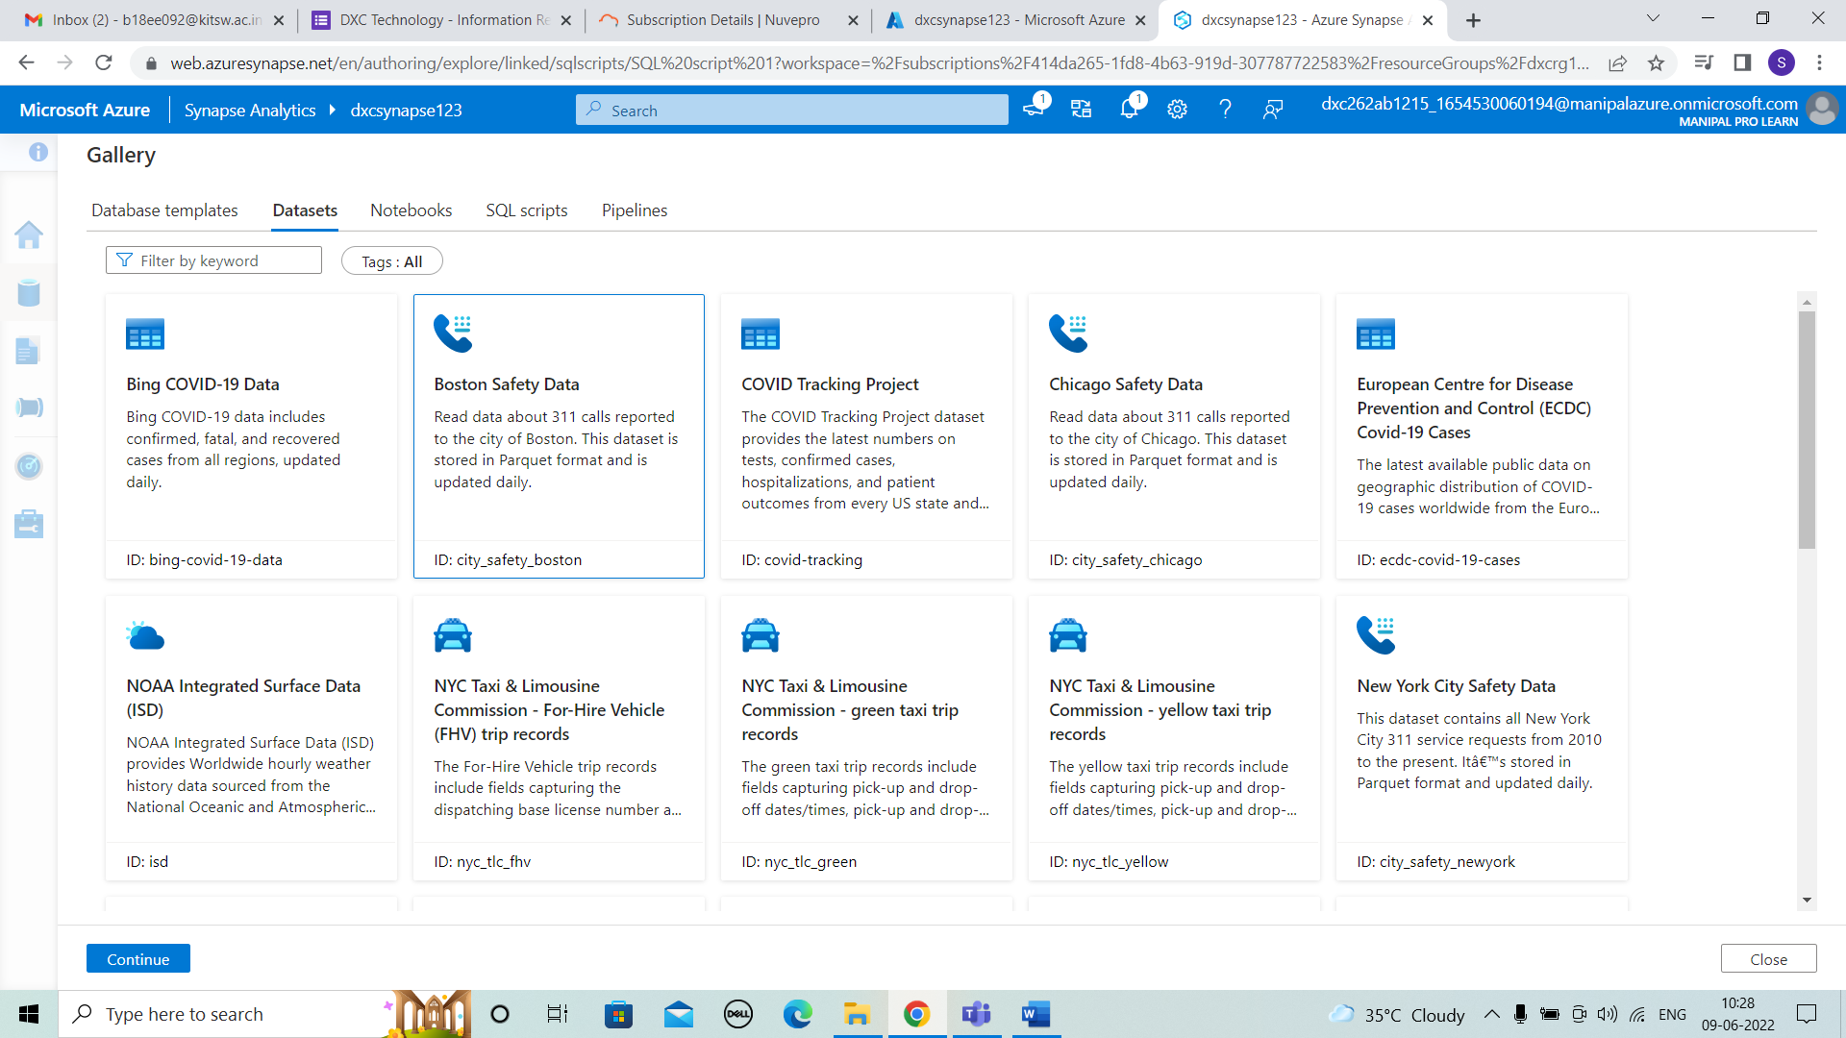



STEP 3: After the dataset is added and run ,we con observe the results as table

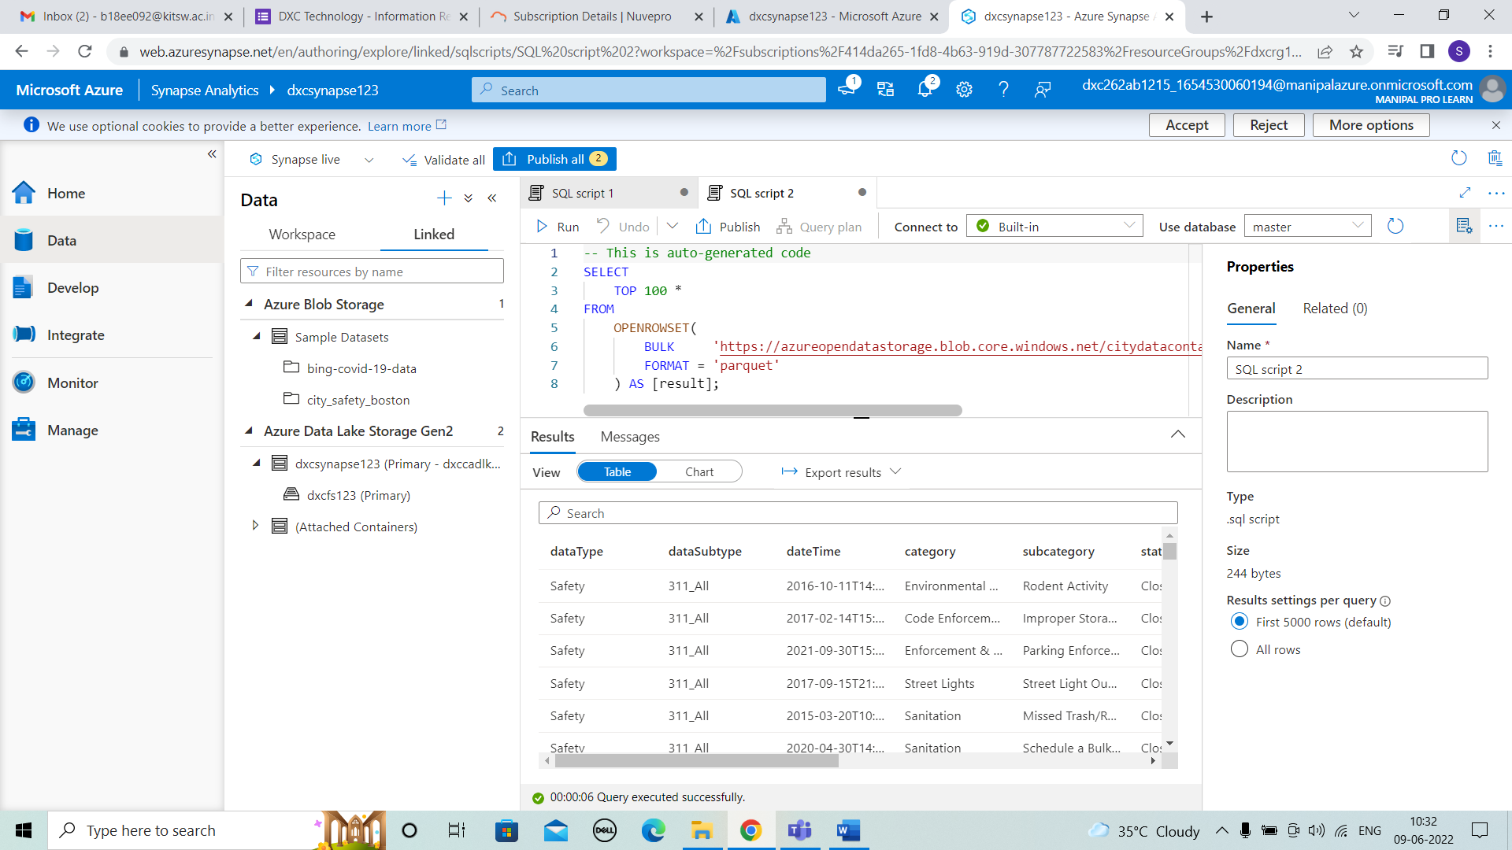



STEP 4: After running we have to publish the data.

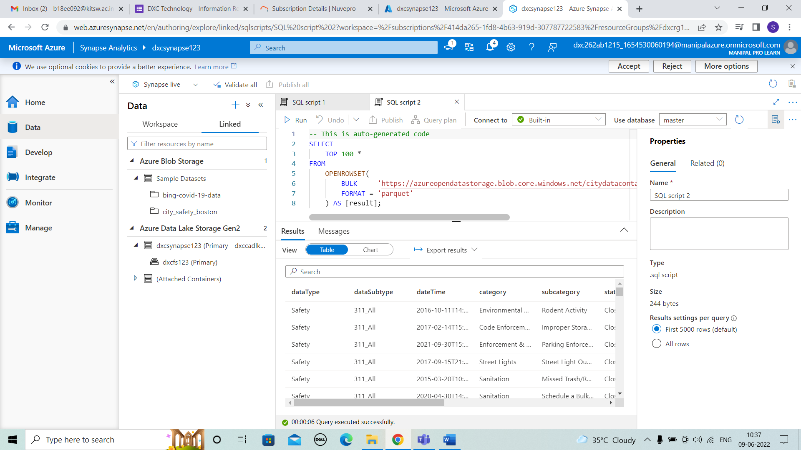



STEP 5:The SQl script is publishes.

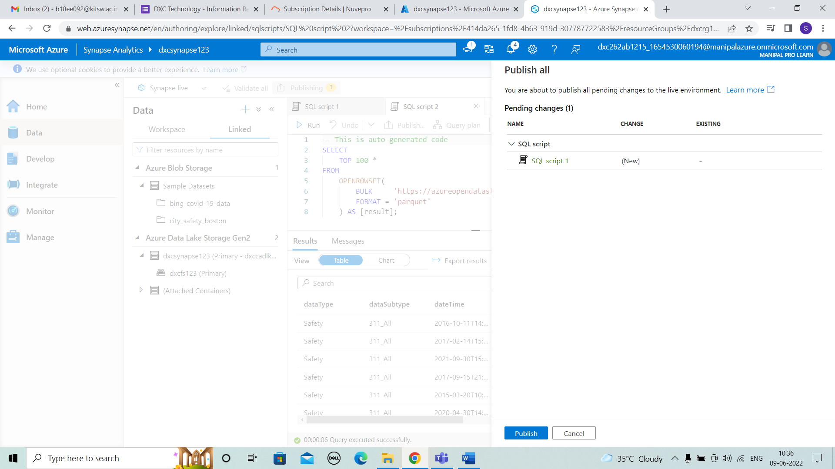



3. Explain the steps with screenshots how to import COVID19 dataset in Azure Synapse analytics, and run sample 500 rows & display the output?

SOLUTION :

STEP 1: After creating the synapse click on the ingest.

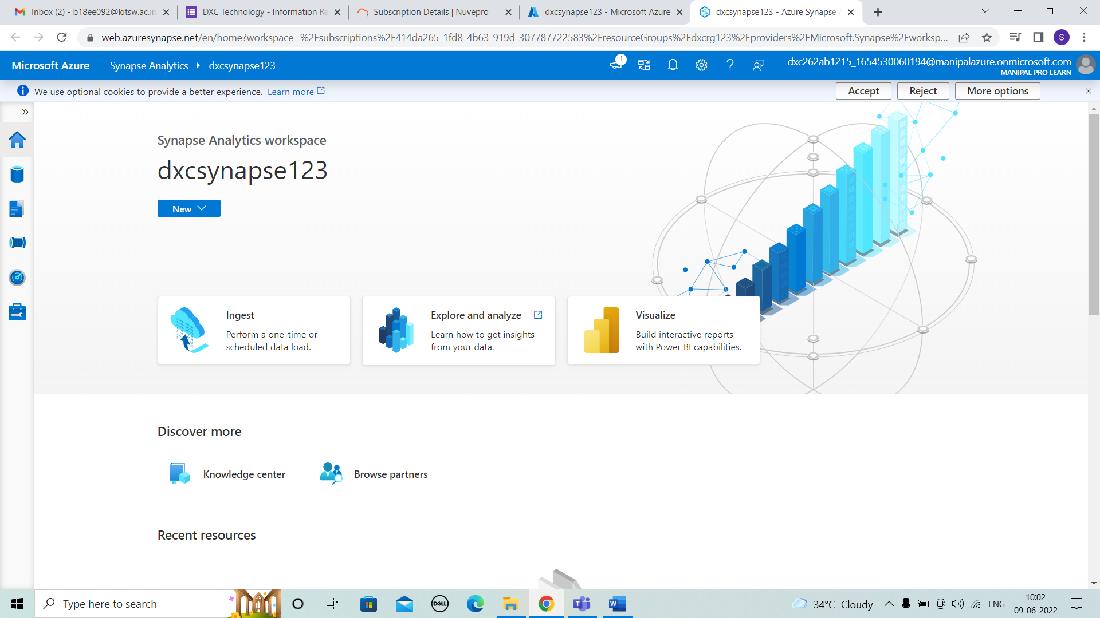



STEP 2: After opening ingest ,Click on data we can observe the + symbol where we give the data into it.

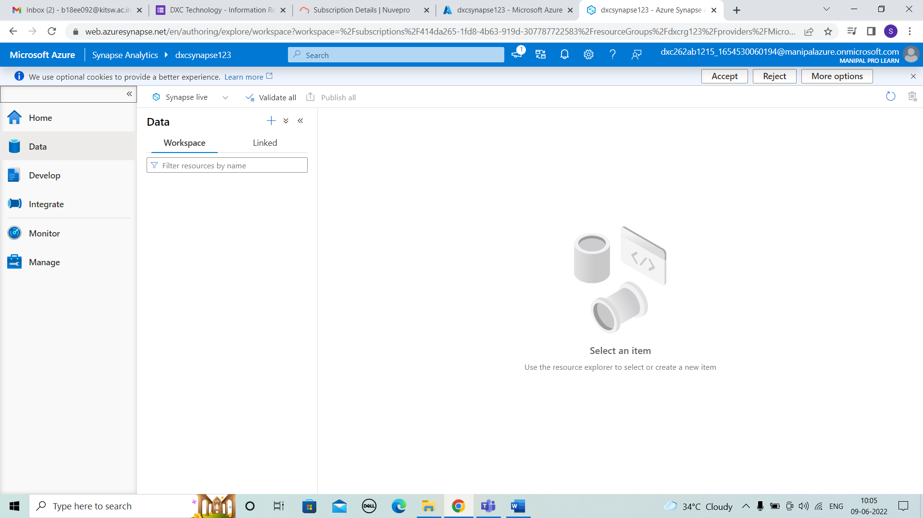



STEP 3: After clicking on “+” we can see browse gallery and then in that we can observe different kinds of datasets.

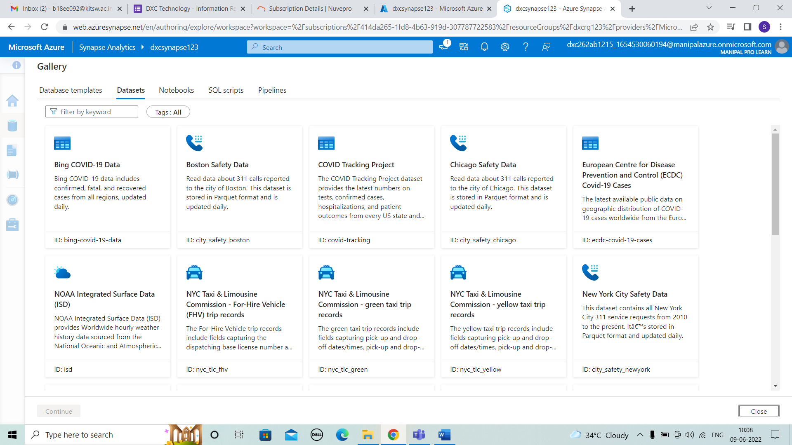



STEP 4: After choosing bing COVID-19 Data ,we will get preview of details and then we have to add the dataset.

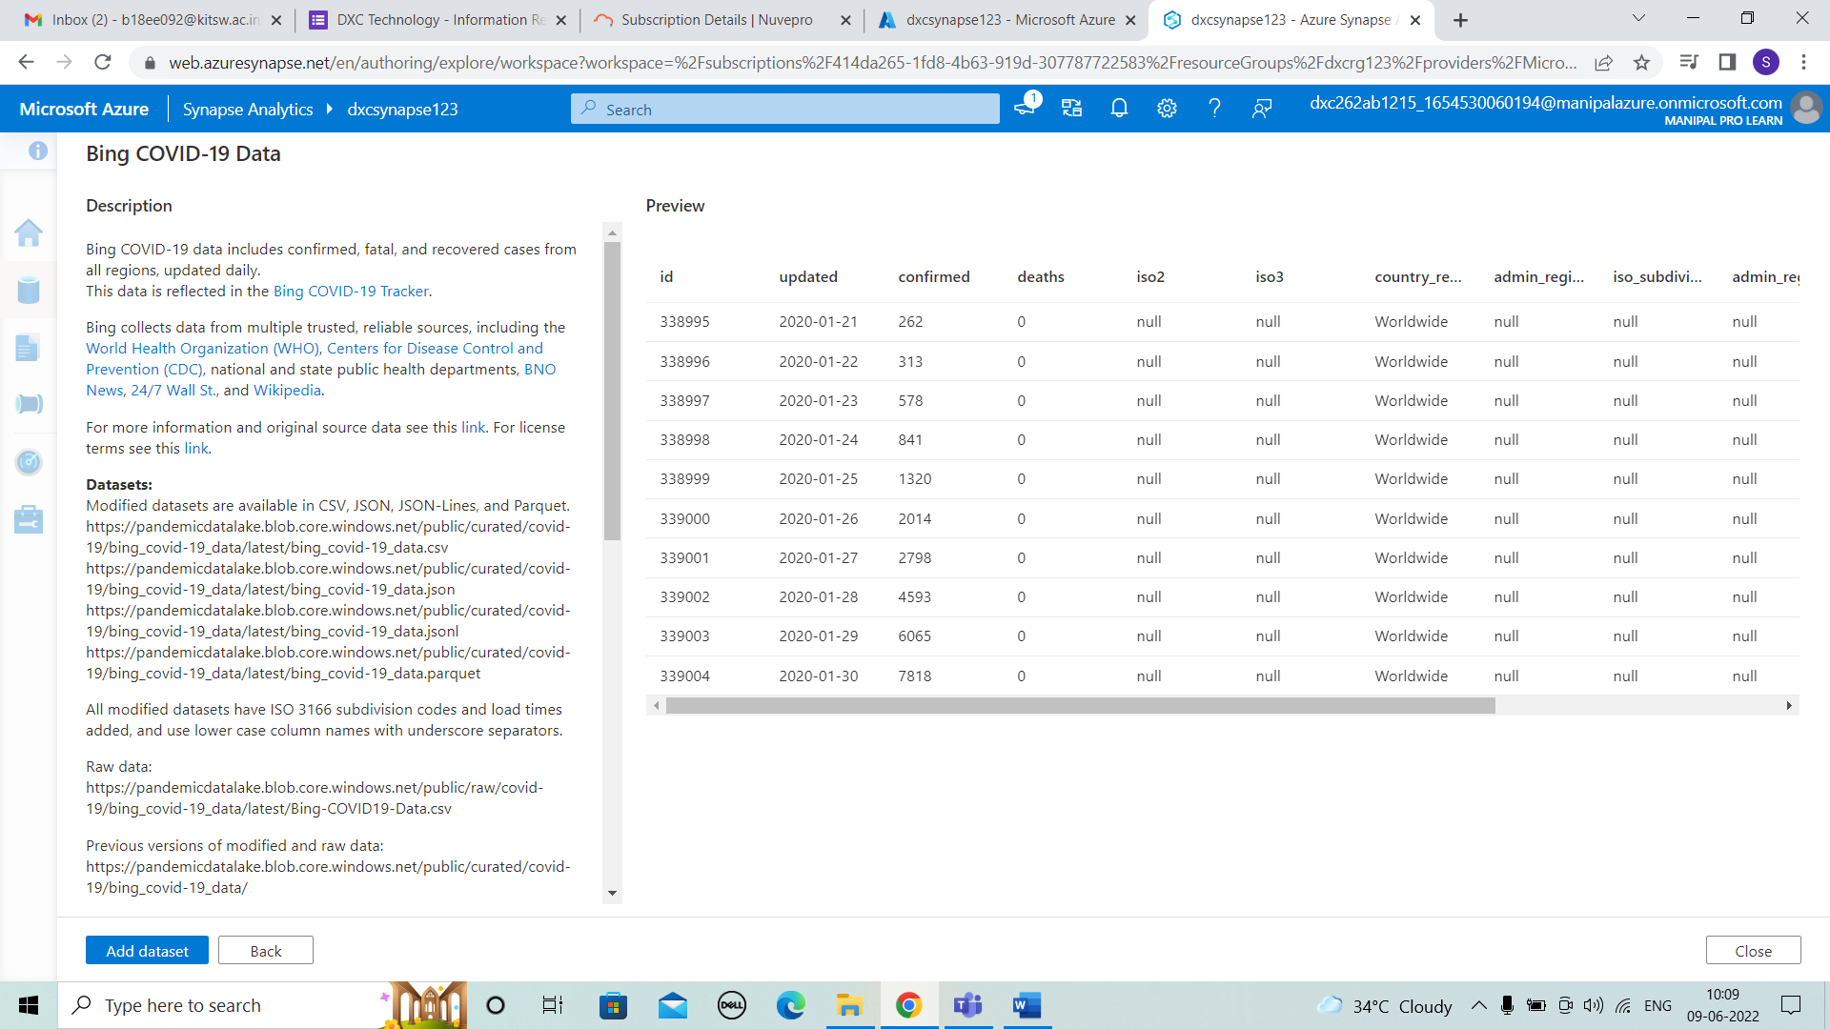



STEP 5:And we can see the dataset in data column . And then right click we can see new sql script and selecting top 100 rows .

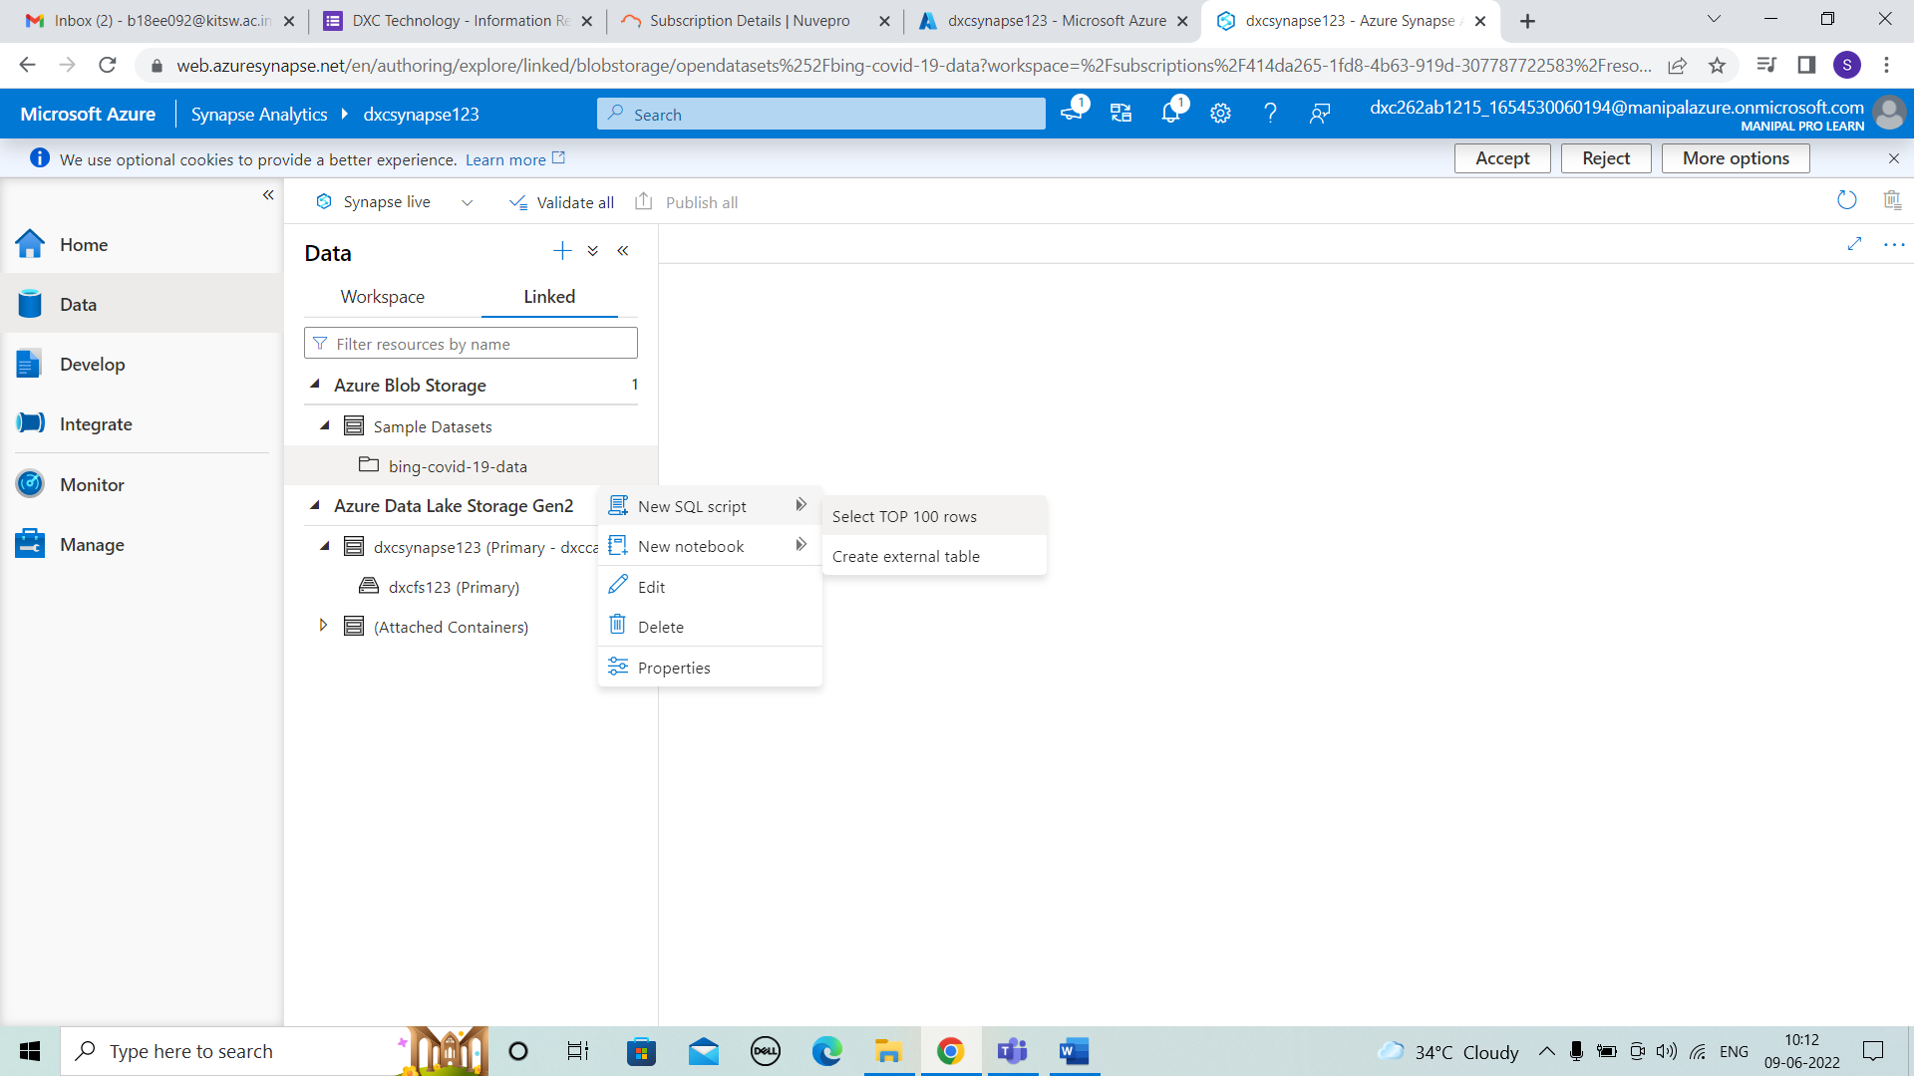



STEP 6: After clicking we can observe the details displayed by running it . The table is displayed in results.

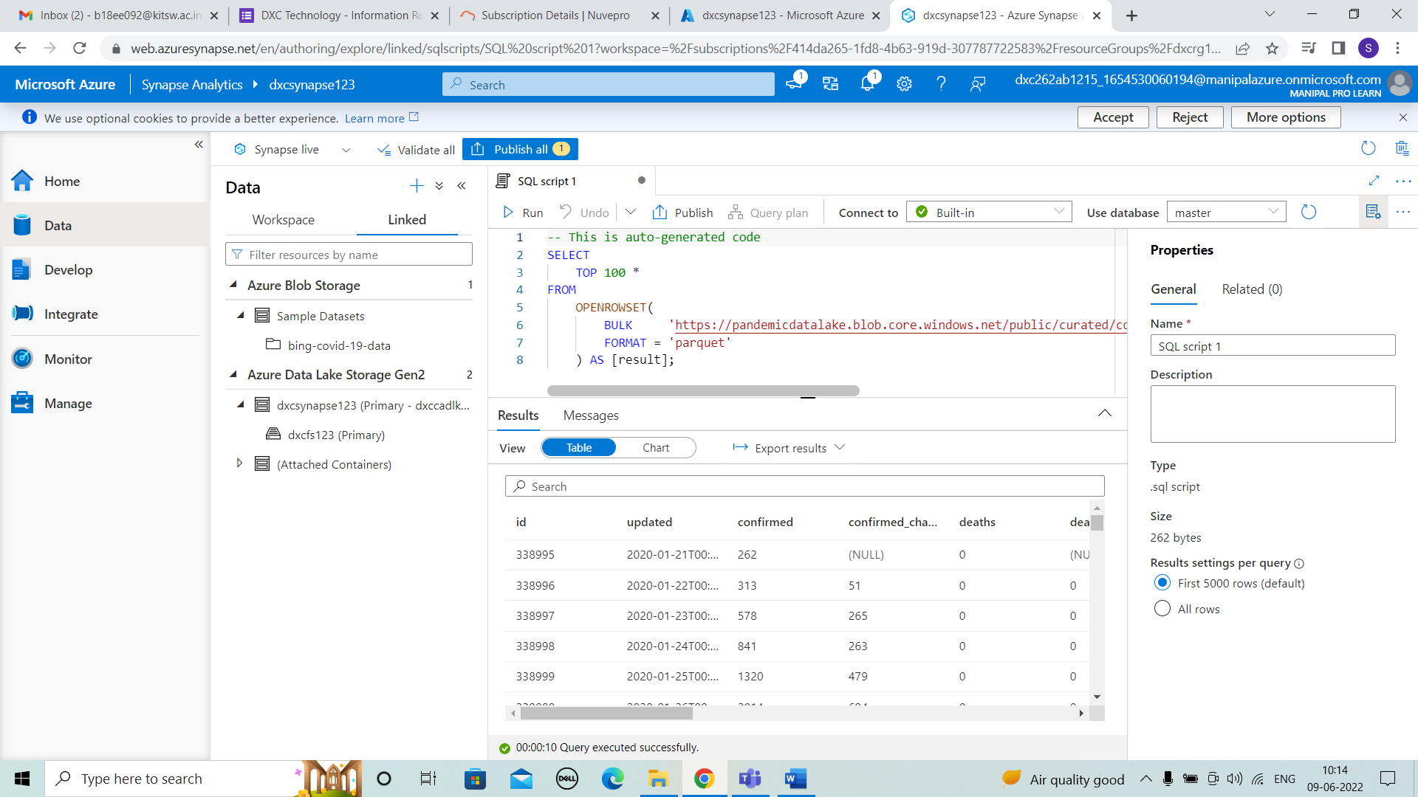



STEP 7: We can also view the result in chart formats of different kinds by choosing the type and requires columns. In below figure we can see the line graph of dataset.

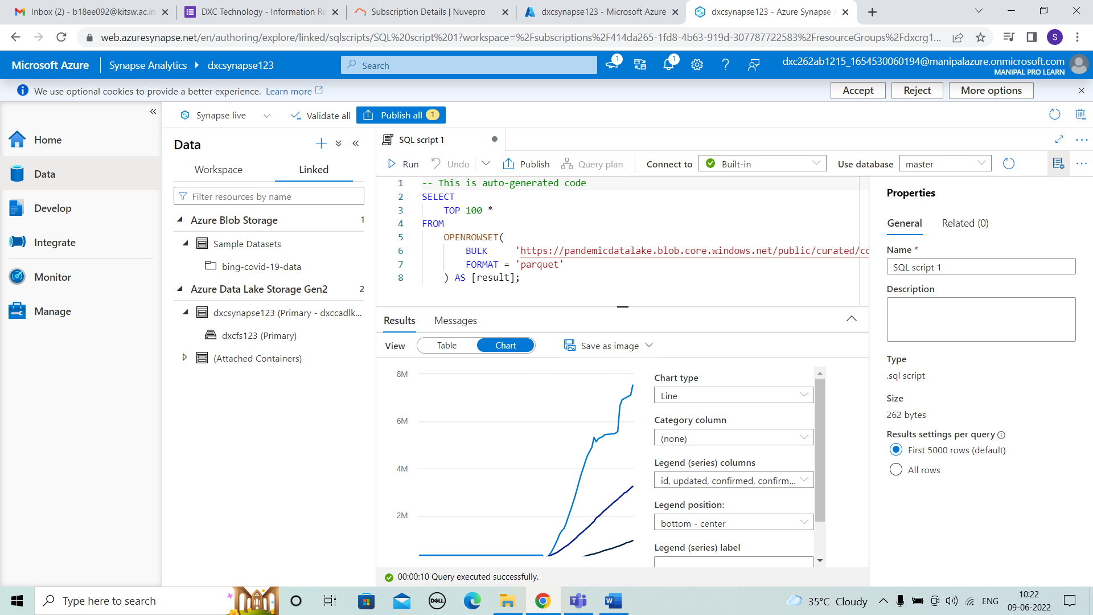



STEP 8: In similar way we can choose pie chart by category column of death and position and other things.

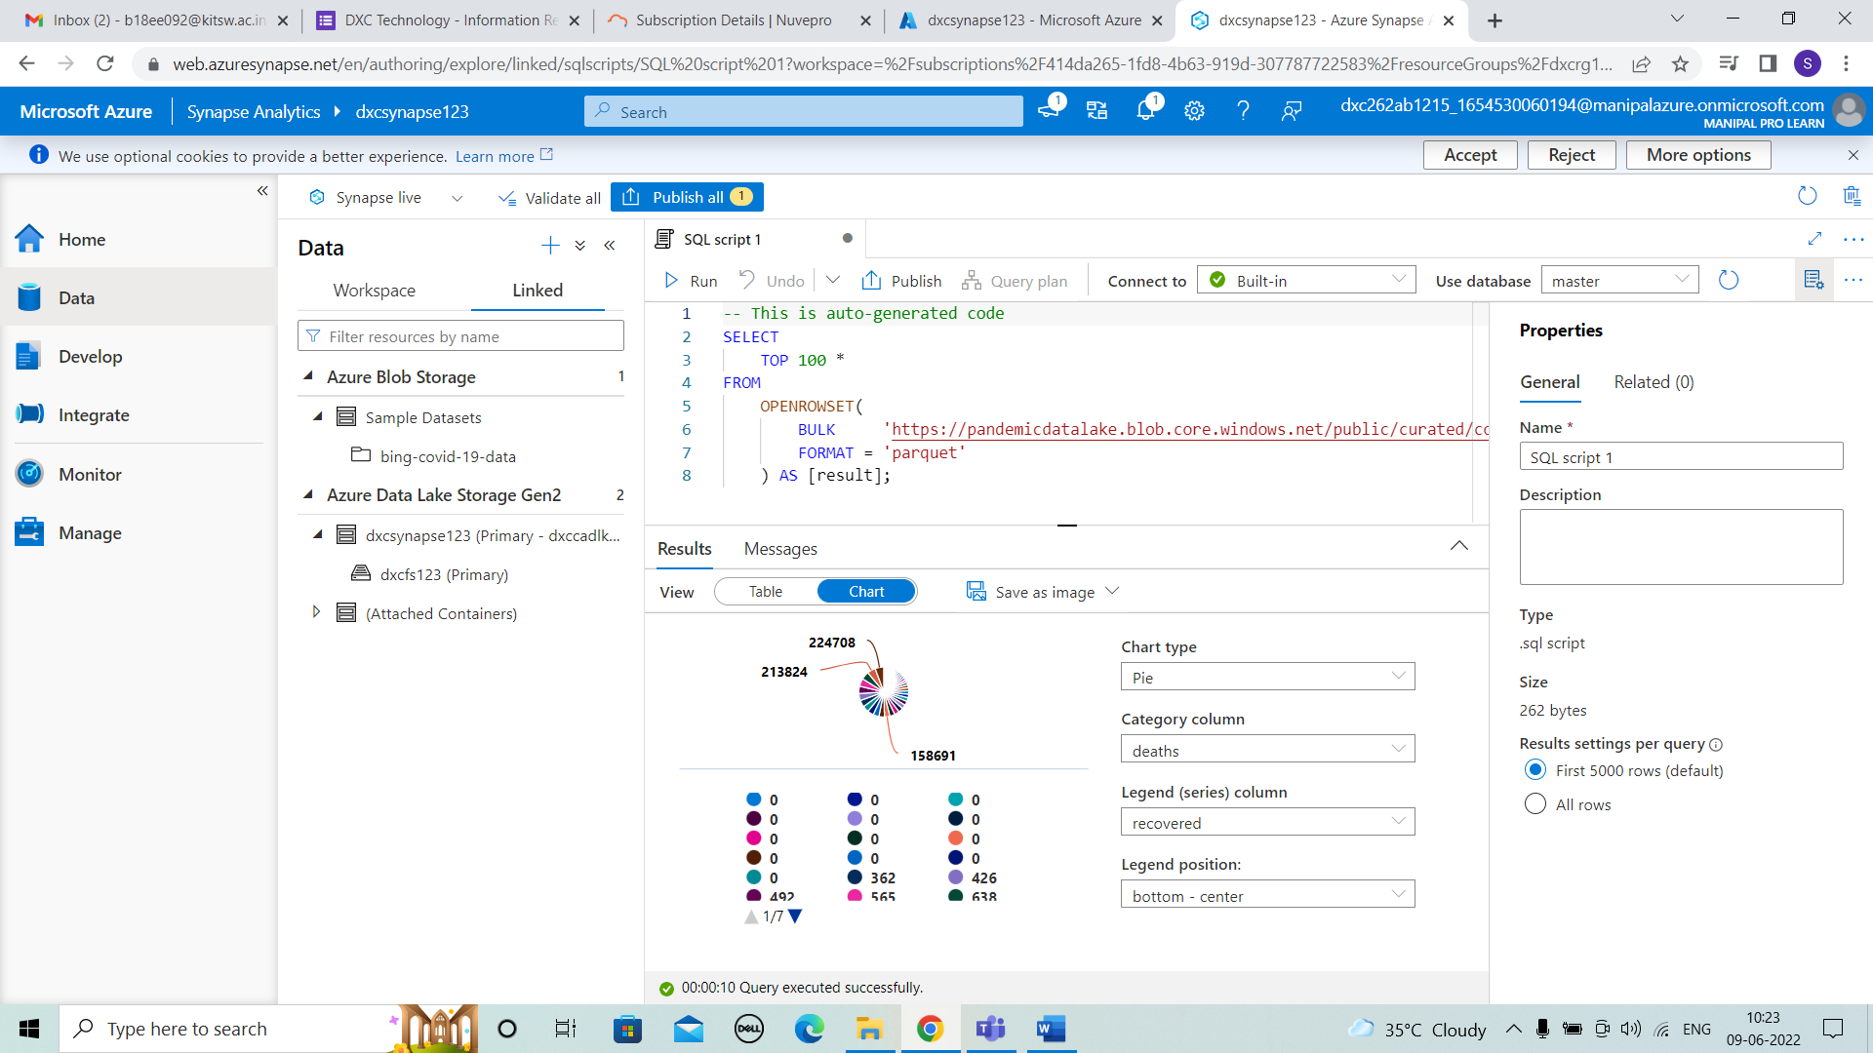



4. Explain the steps with screenshots how to input Boston Safety datasets into Azure Synapse analytics? using Notebooks?

SOLUTION :

STEP 1: For Notebook select spark pool and attach and then run it.

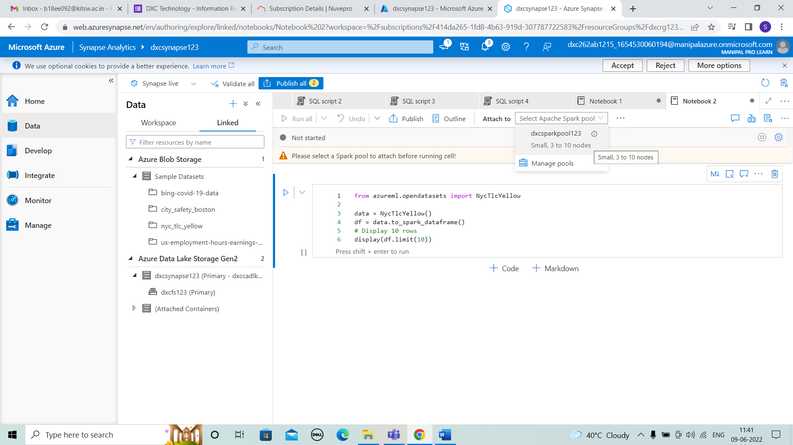

STEP 2:Choose boston and right click > new notebook > load frame

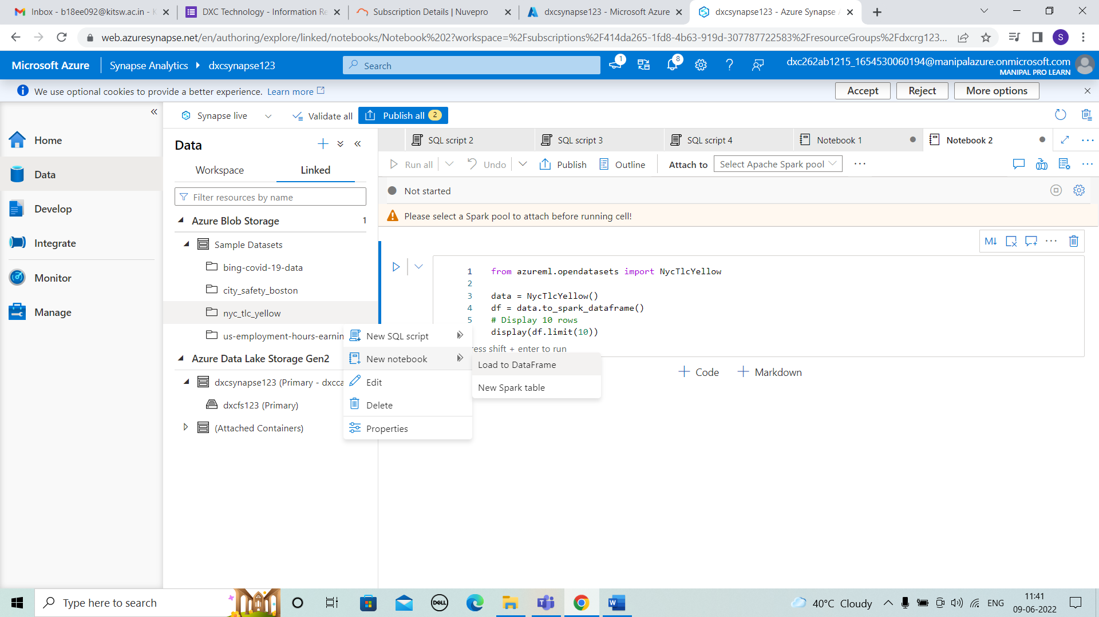

STEP 3: attach spark pool and run it

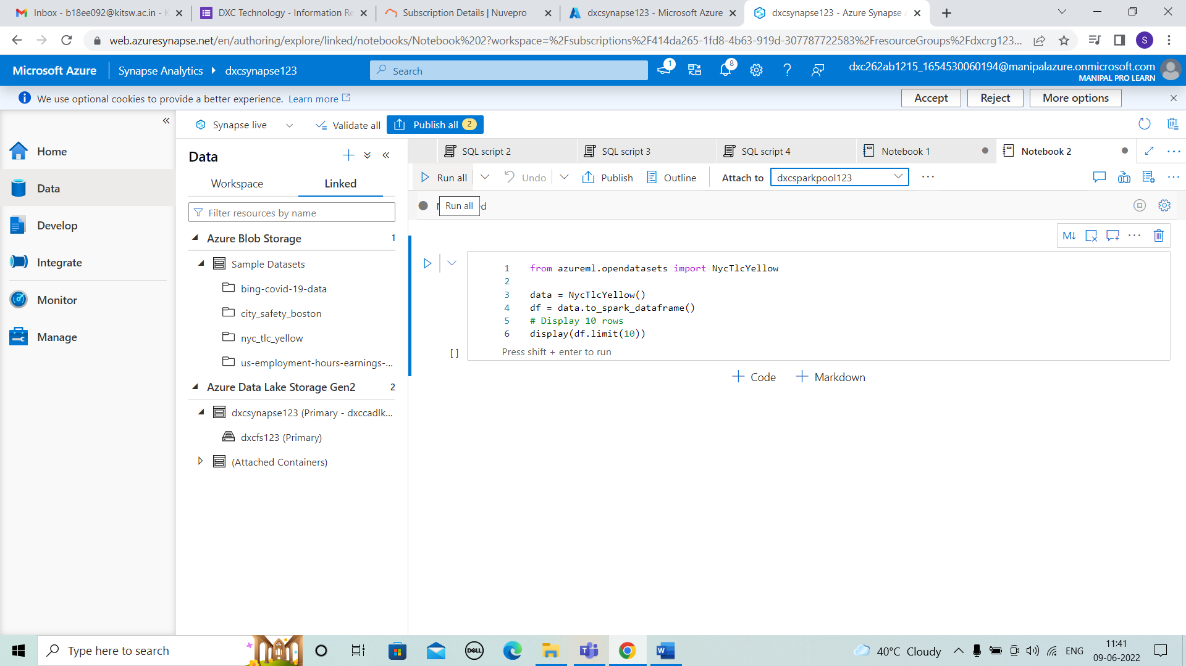

STEP 4: We get the result for Notebook of boston safety datasets.

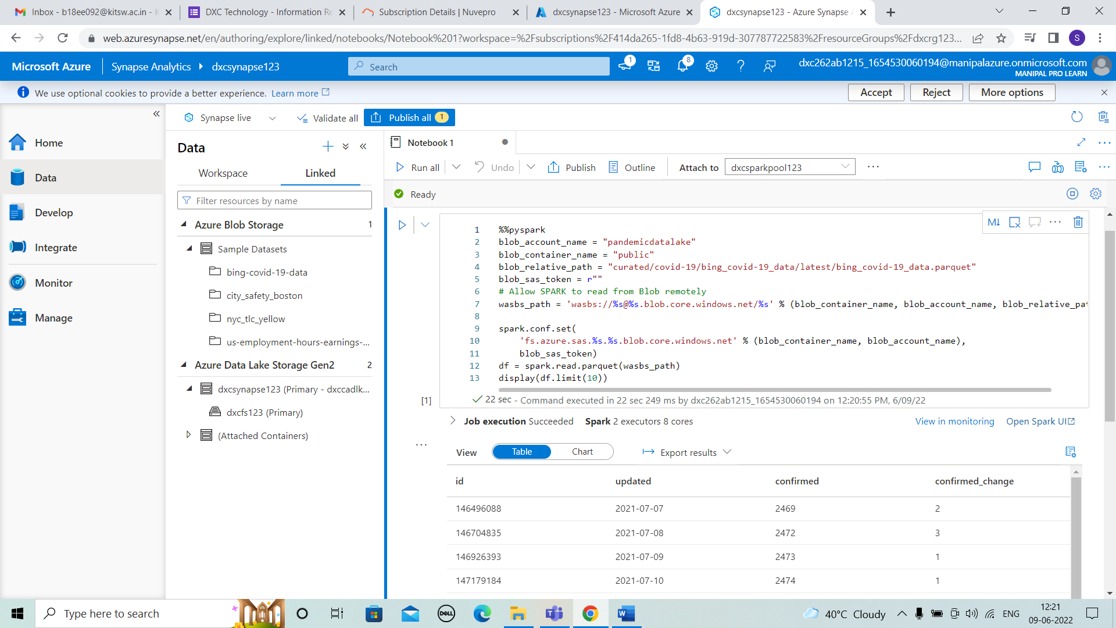



5. Explain the steps with screenshots how to create Spark pool in Azure Synapse analytics? ?

SOLUTION :

STEP 1: For creating spark pool we have to click manage and then select apache spark pool and click on new+.

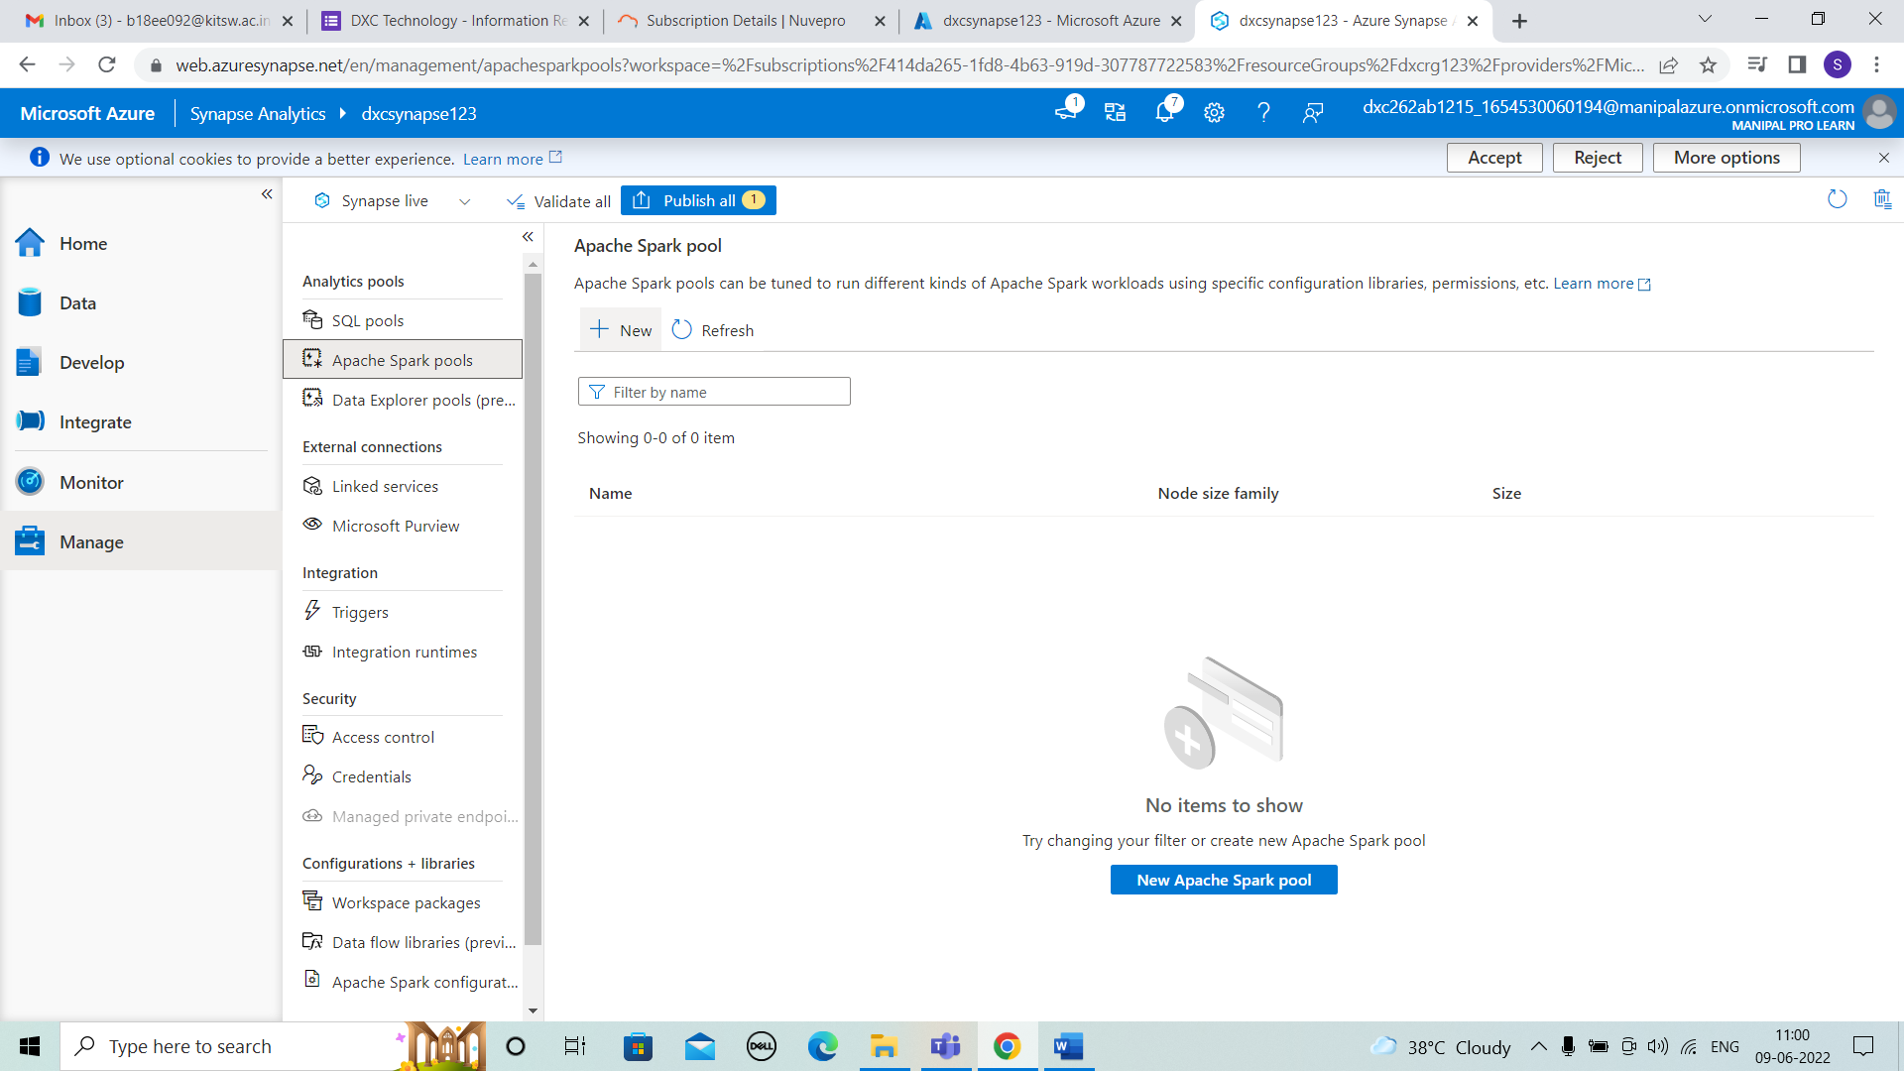



STEP 2: After that we see the basics of details and fill the details as shown below. And click on review create.

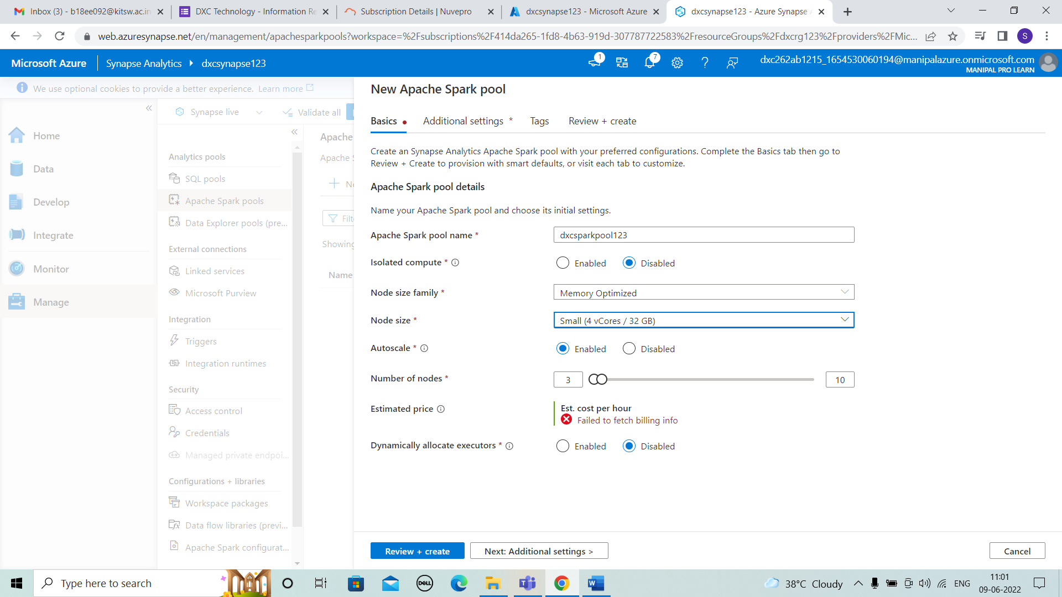



STEP 3: After review+ create , click on create.

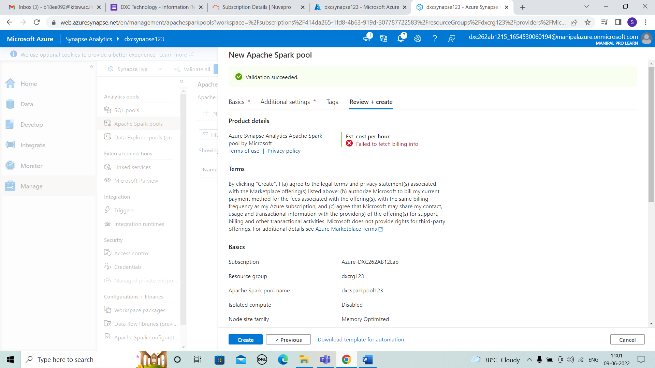



STEP 4: We can observe spark pool is created now we can run the datasets using spark pool.

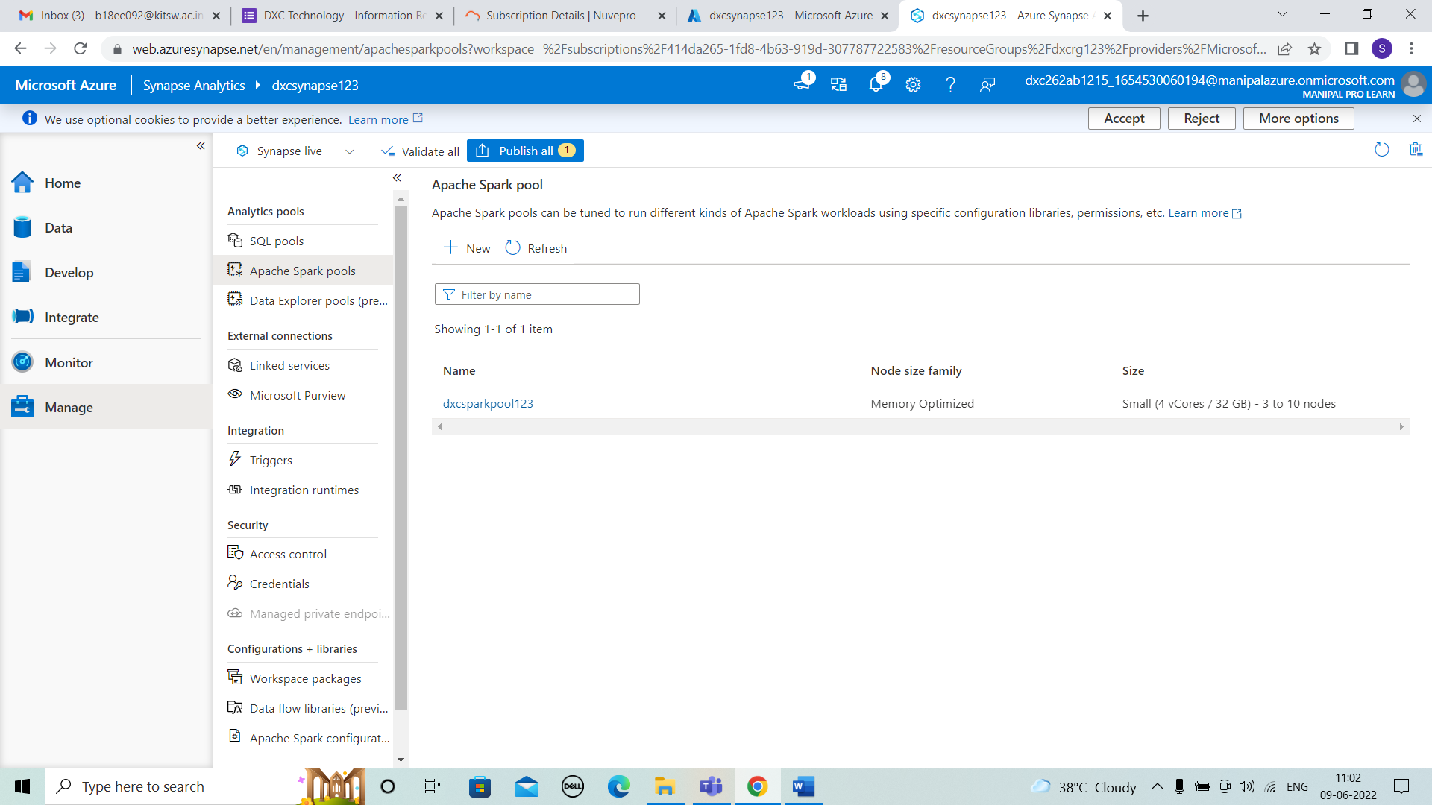



6. Explain the steps with screenshots how to create pipeline in Azure Synapse analytics? ?

SOLUTION :

STEP 1:For pipeline integrate is selected and we have to add the pipeline by using +. Then by synapse the notebook is dragged to shown position. and the settings are given as shown below.

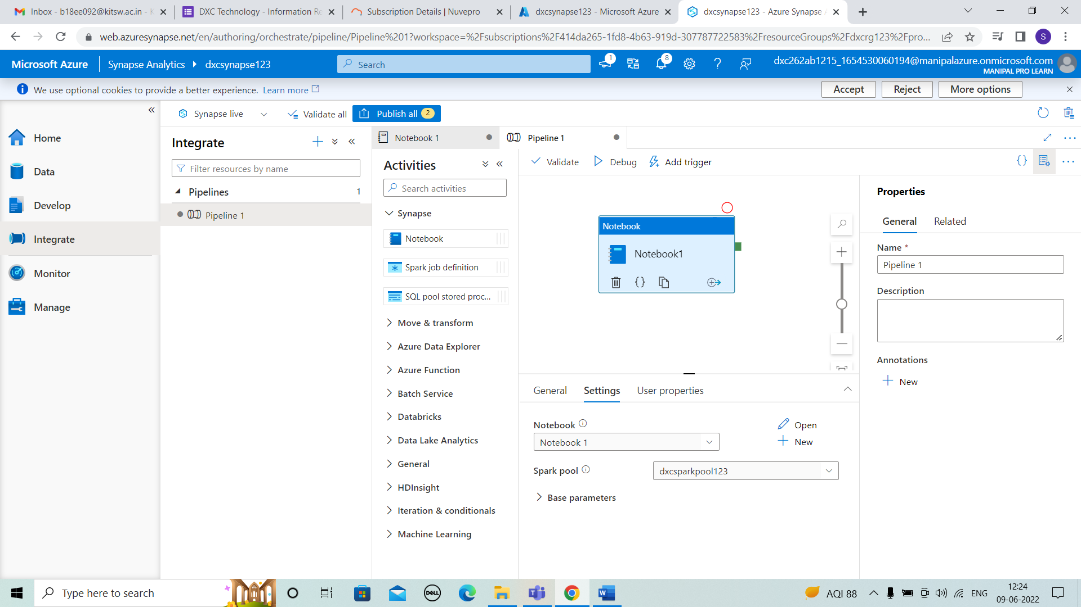



STEP 2: Then validate and it will run.

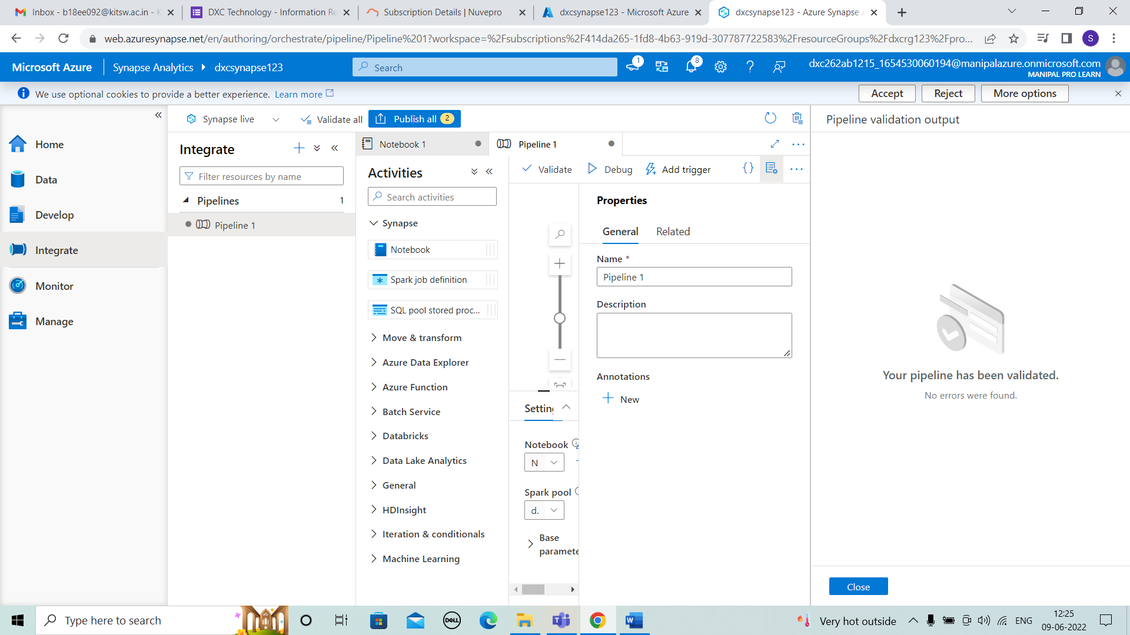



STEP 3:After running the notebook is published.

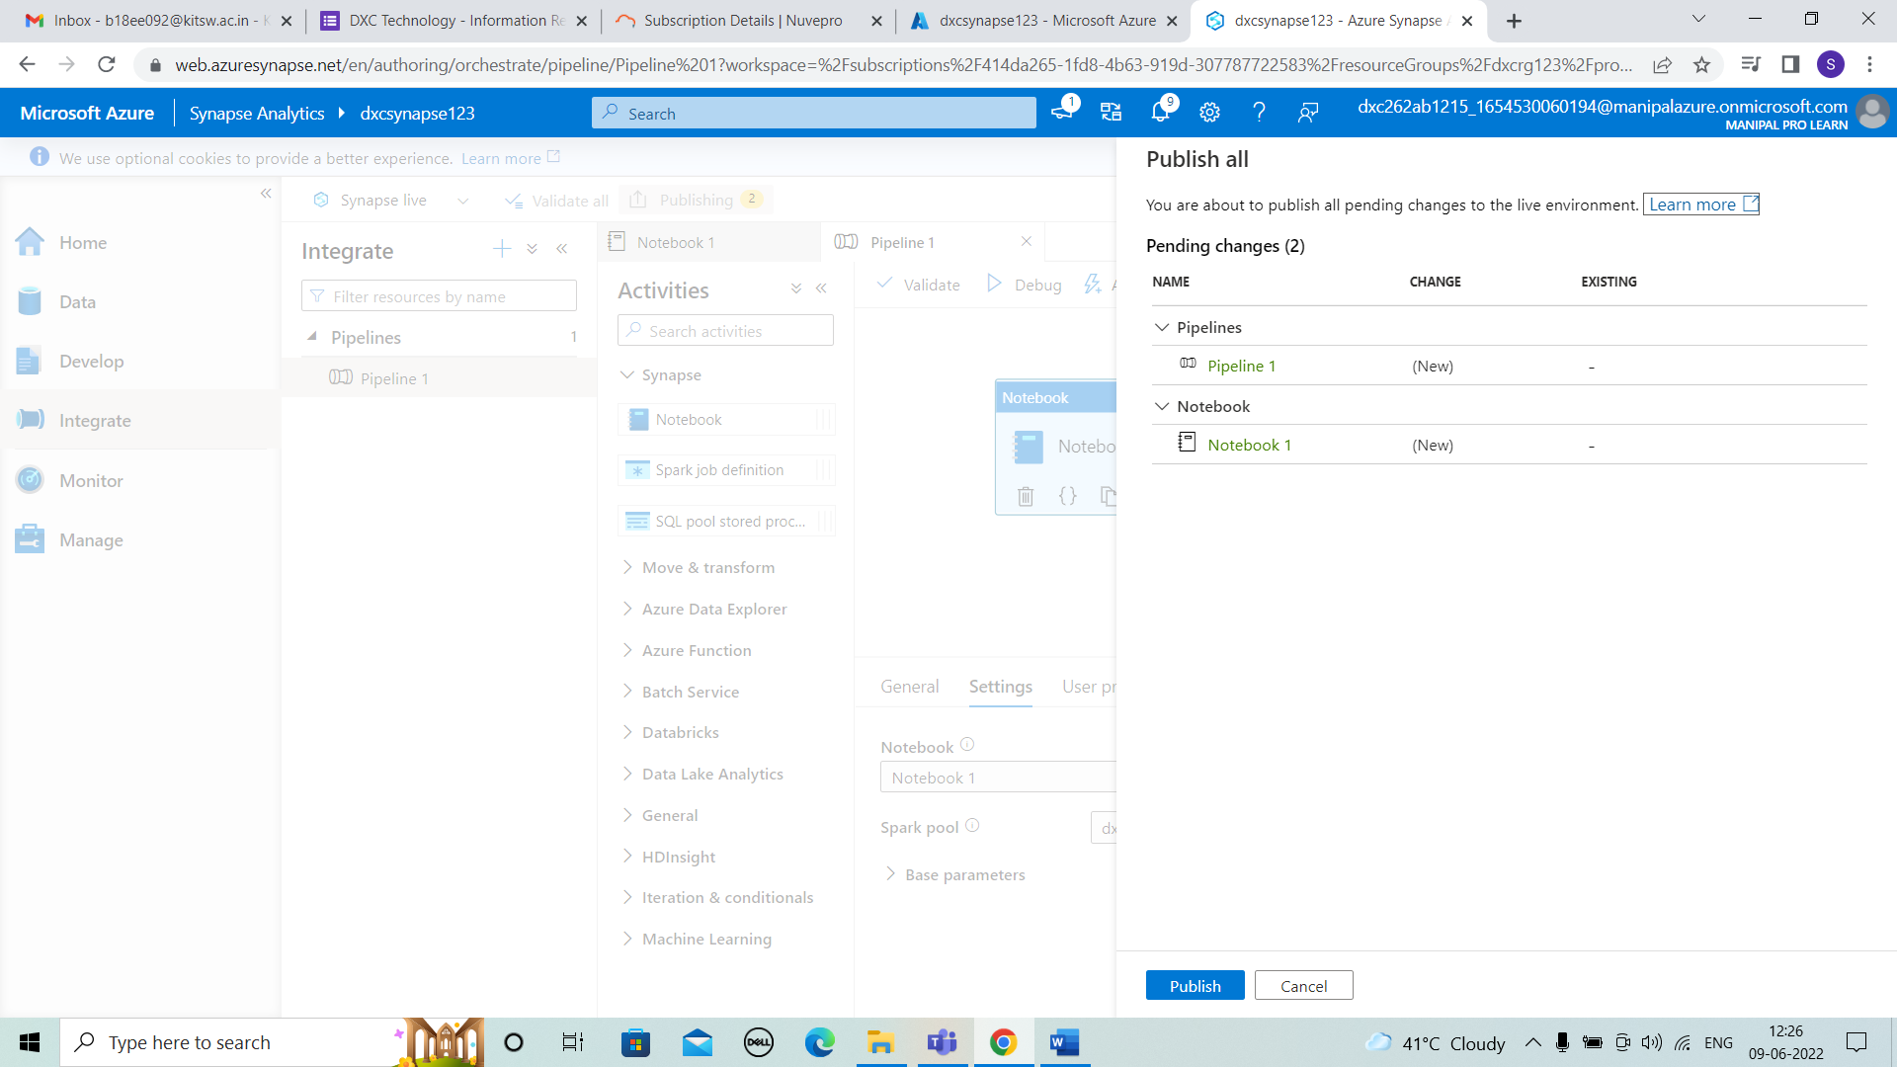



STEP 4:Then trigger and select ok .

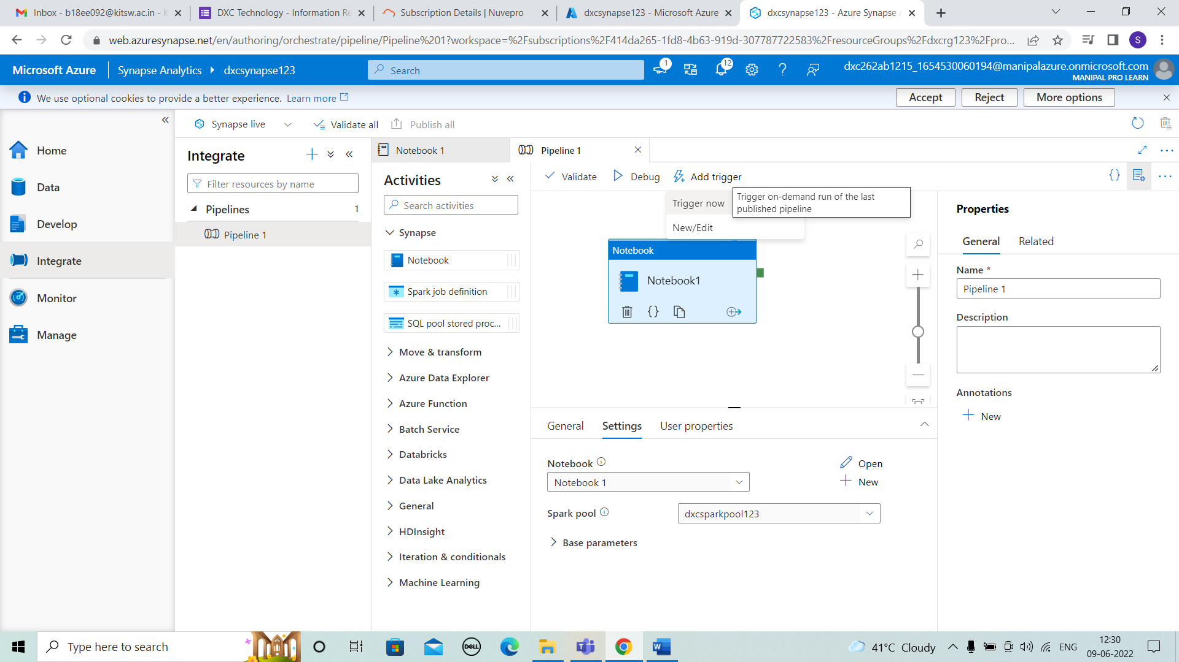



7. Explain the steps with screenshots how to automate the pipelines in Azure Synapse analytics??

SOLUTION :

STEP 1: It will run after triggering and we can see result in

Monitor later.

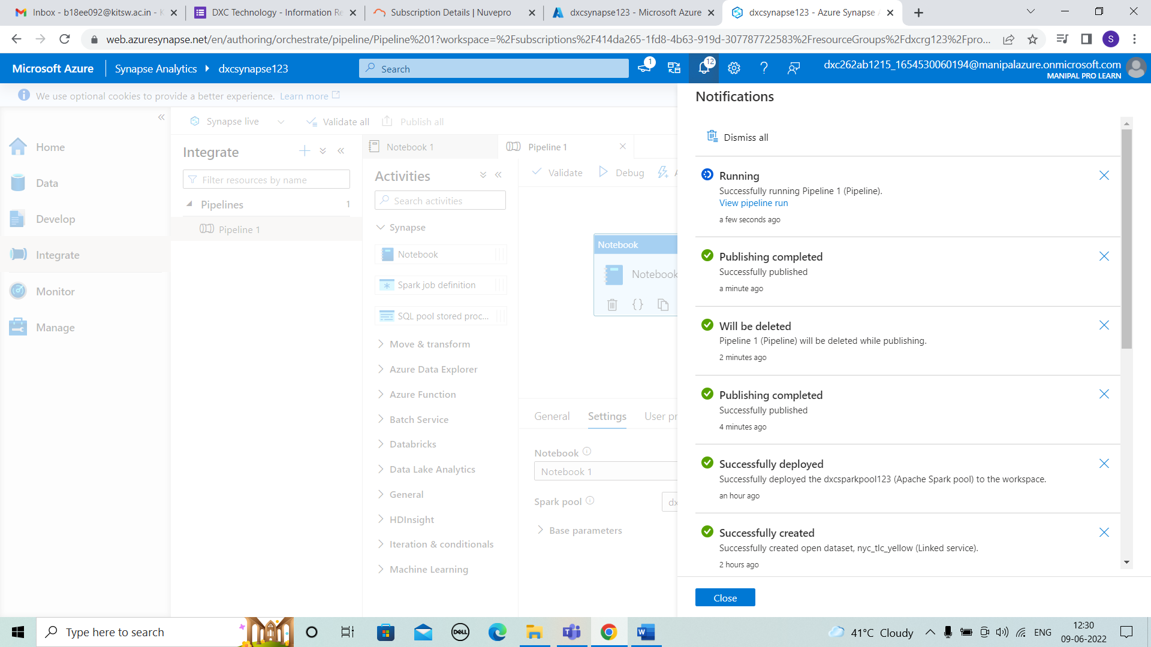



STEP 2:After that add other pipeline and add another notebook and select settings and validate.

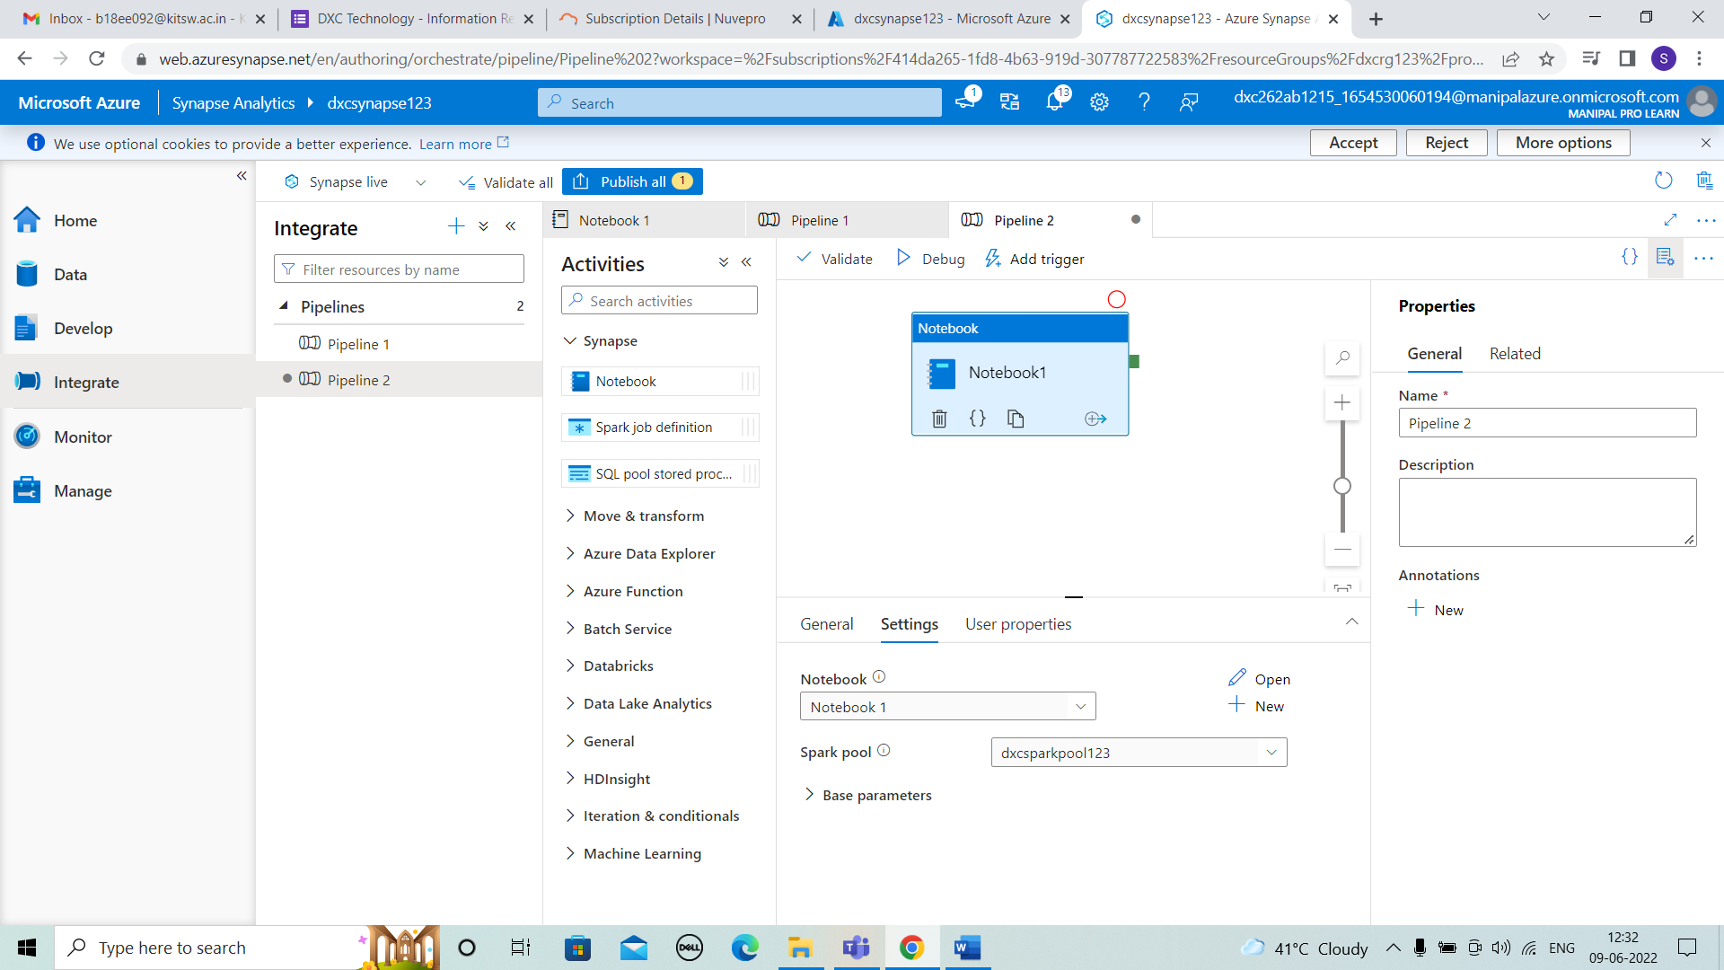



STEP 3: The pipeline 2 is published.

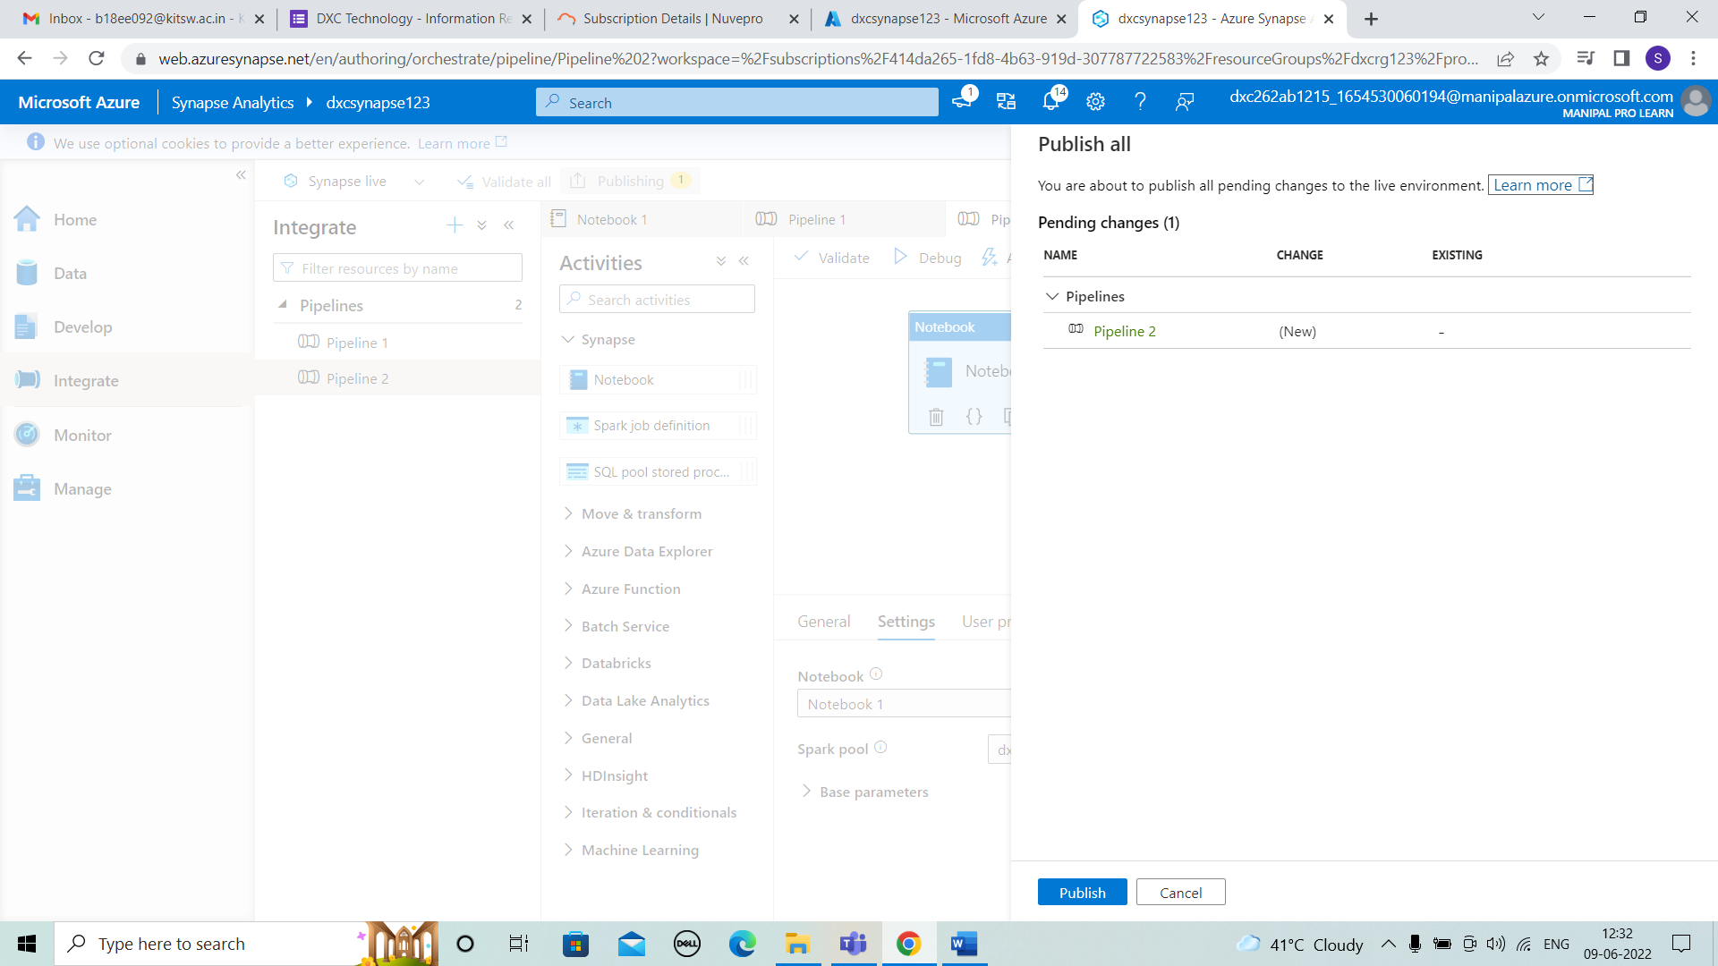



STEP 4: Trigger is done and running of code takes place.

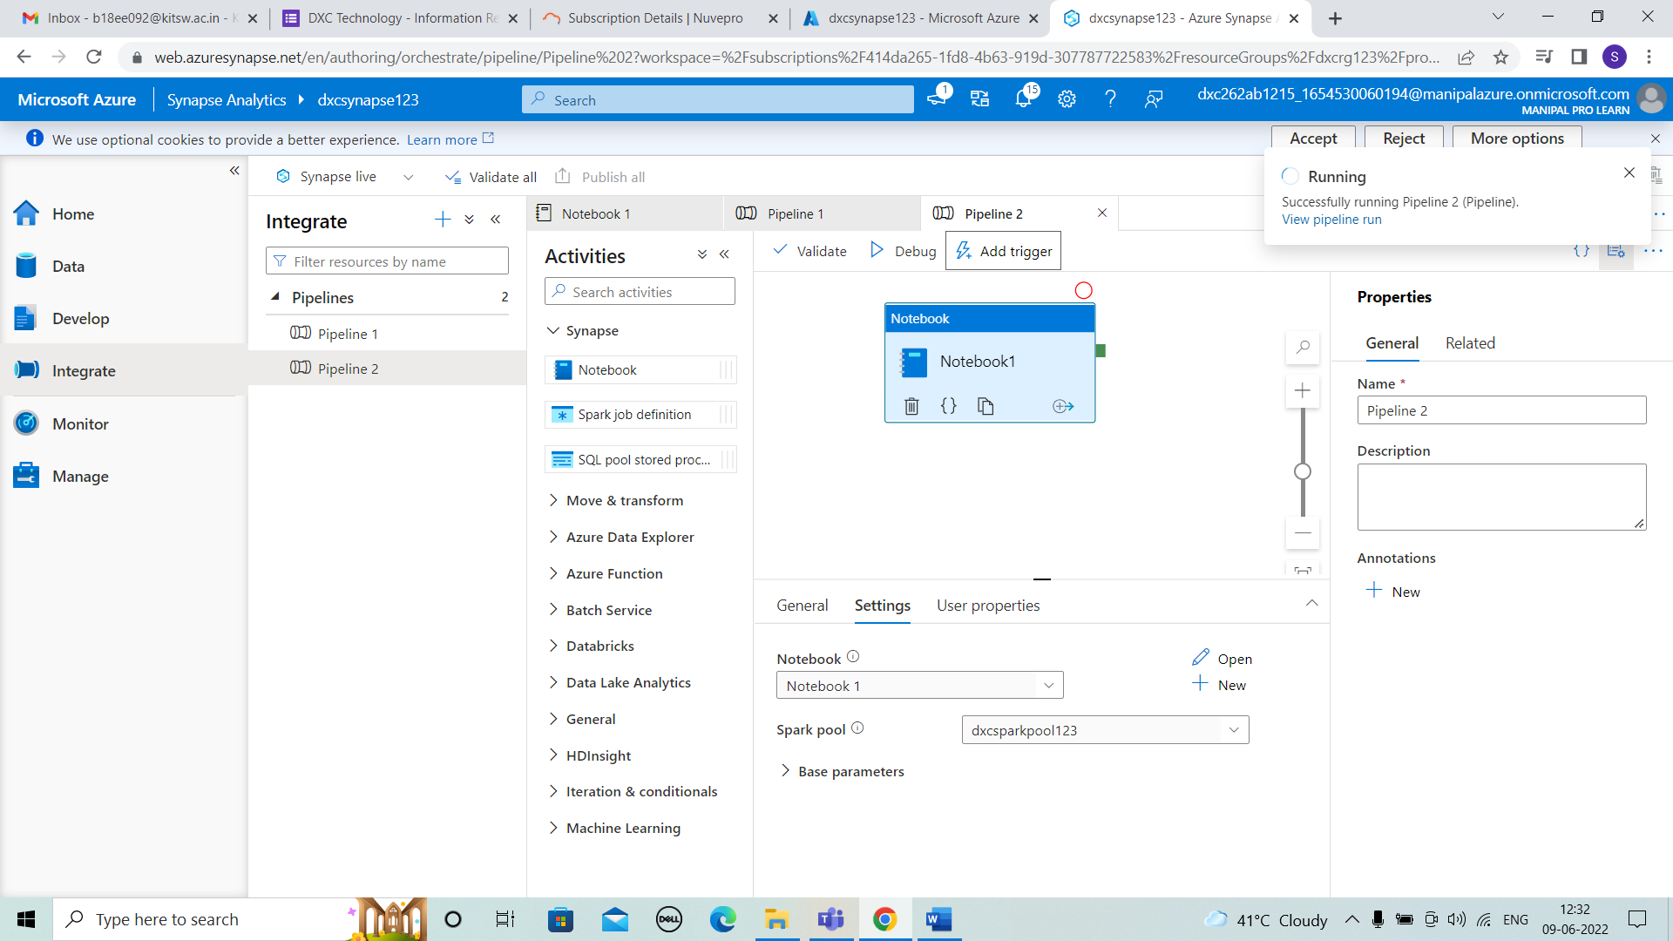



STEP 5: We have to trigger by selecting ok after validating.

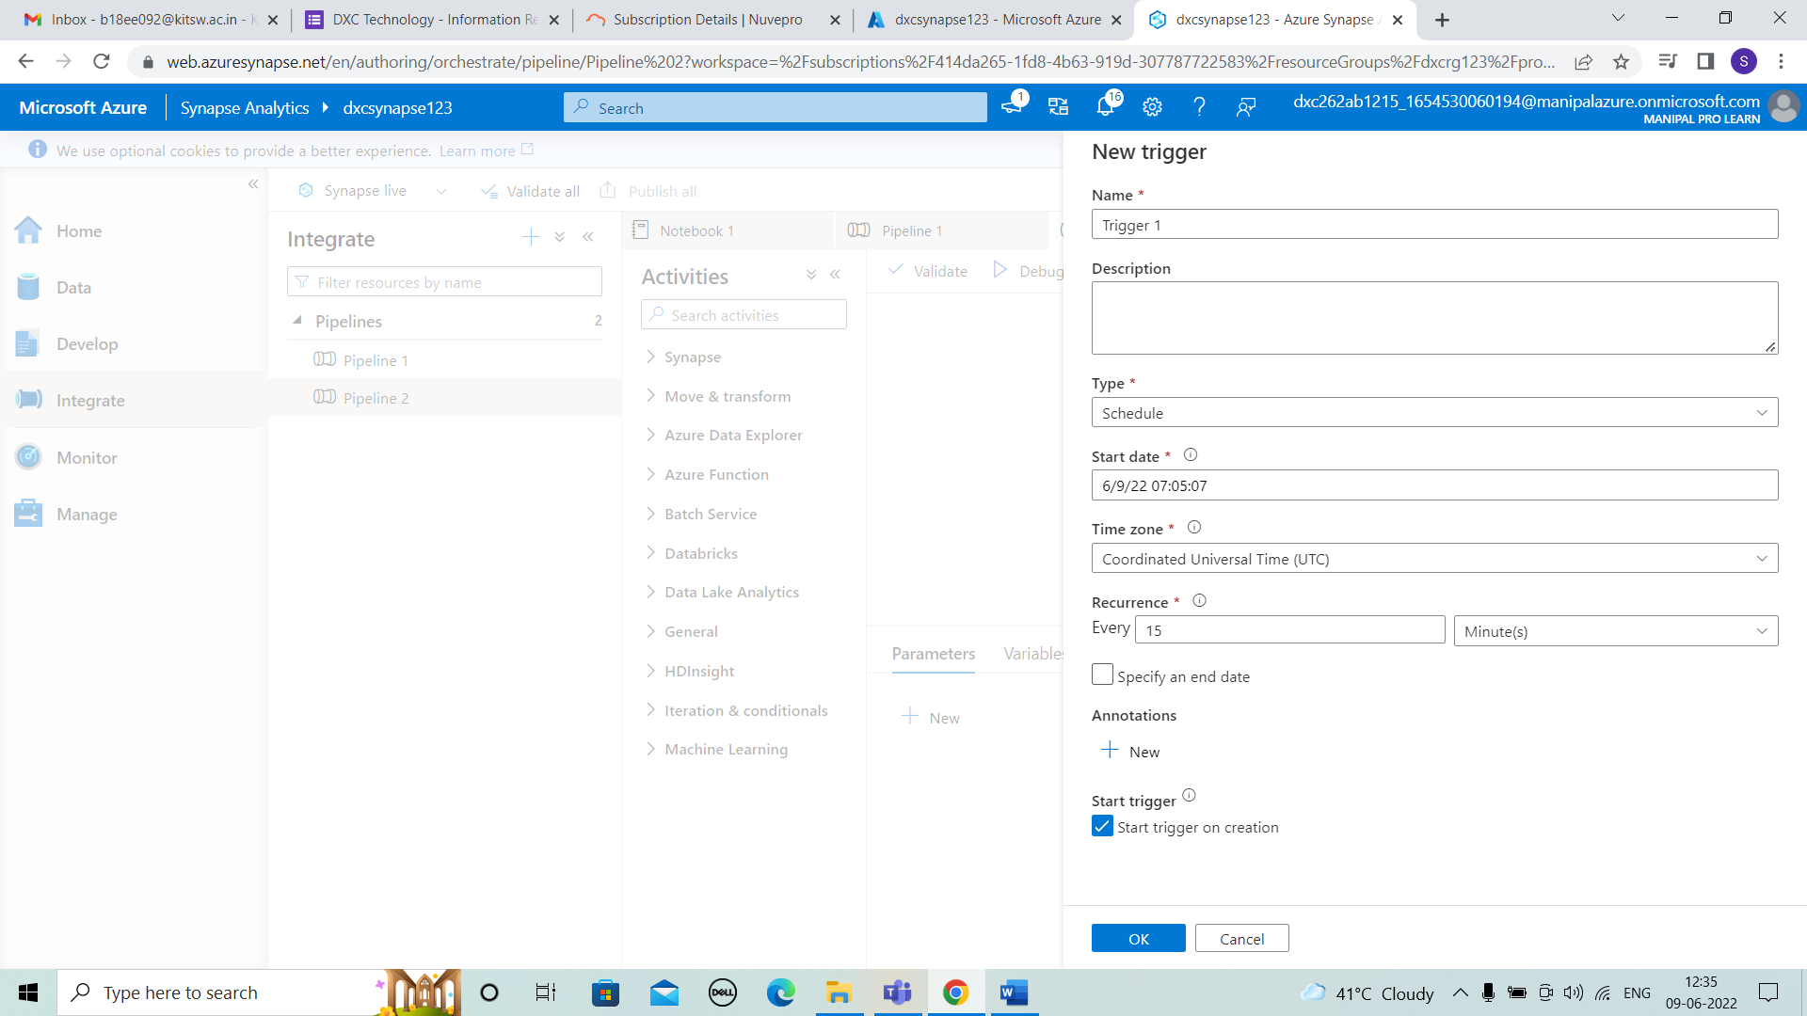



STEP 6: After triggering the notebook is published.

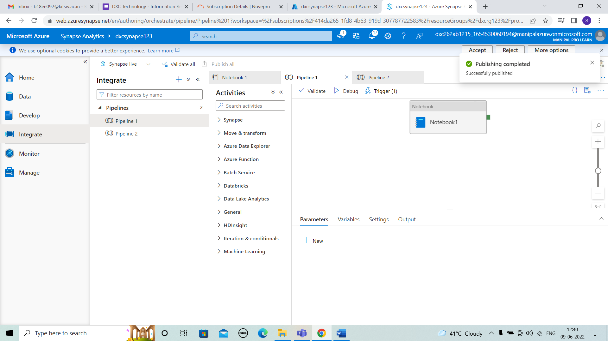



STEP 7: These are the results of running and we can observe this in monitor.

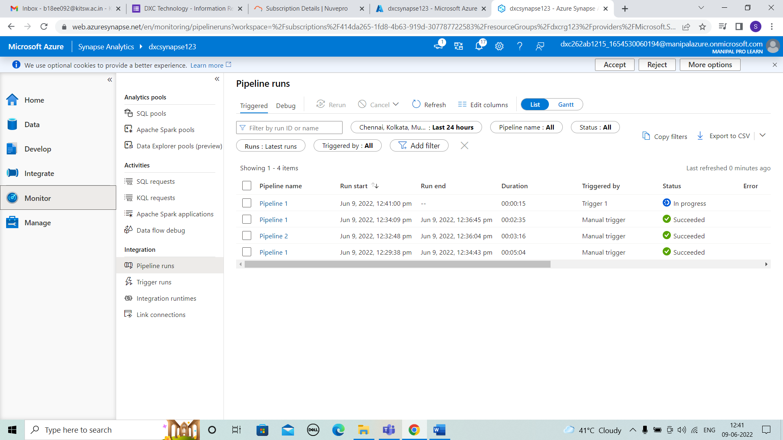



STEP 8: After changing the trigger settings and time intervals for code running.

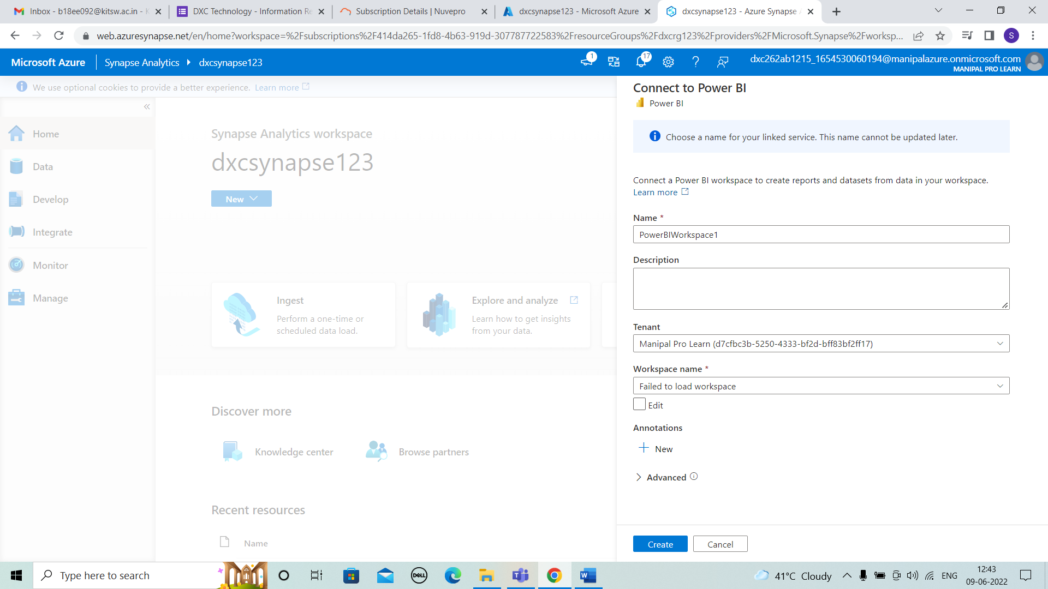



STEP 9: These are the results after choosing the trigger settings.

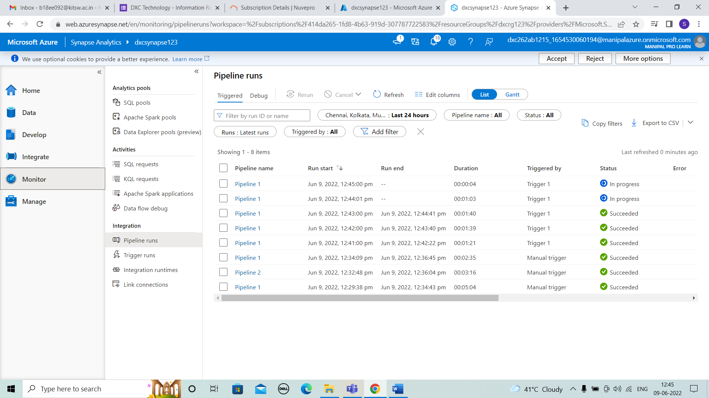

STEP 10: After few minutes,We can see the pipe lines are running at every point of time we choose in trigger.

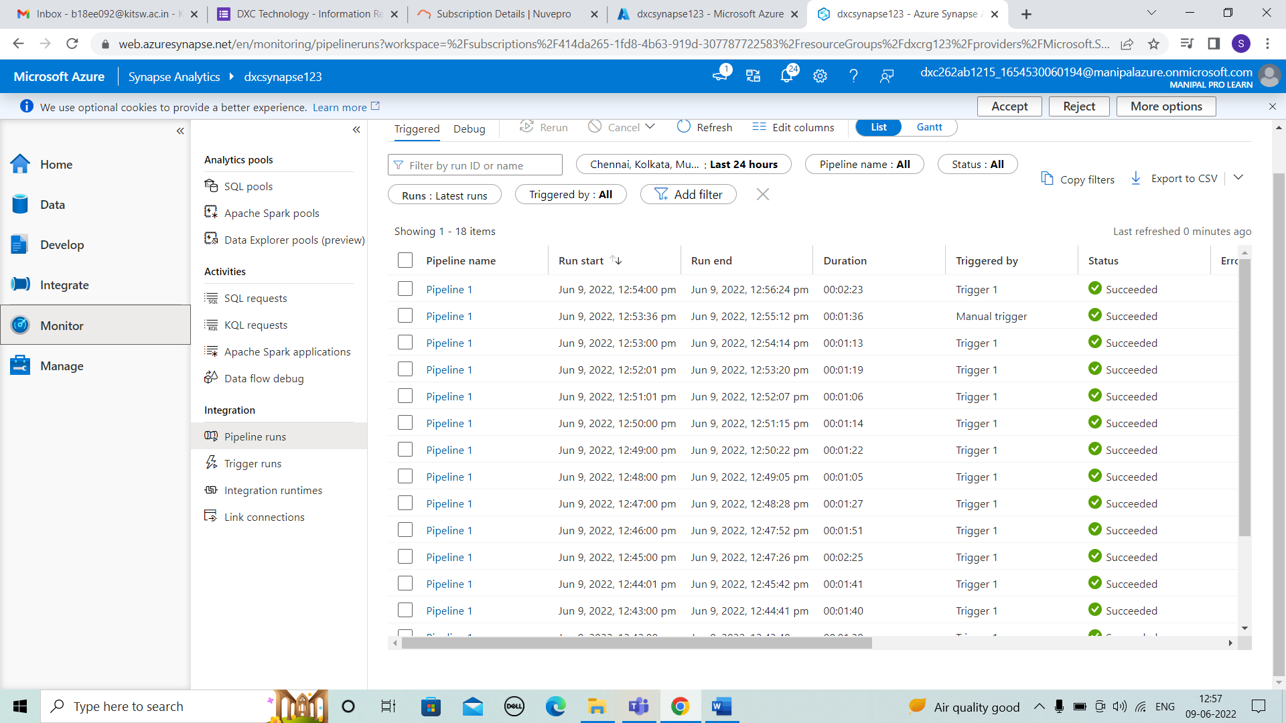

8. Explain the steps with screenshots how to Databricks ?

SOLUTION :

STEP 1: Search the data bricks and click on azure data bricks.

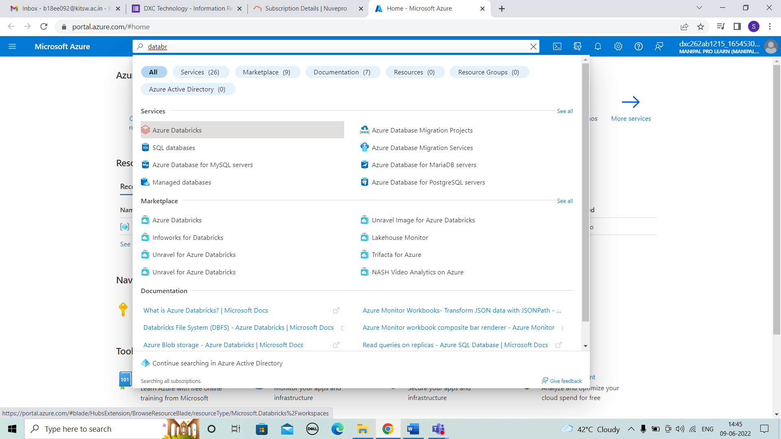



STEP 2:After entering into the data bricks click on create+.

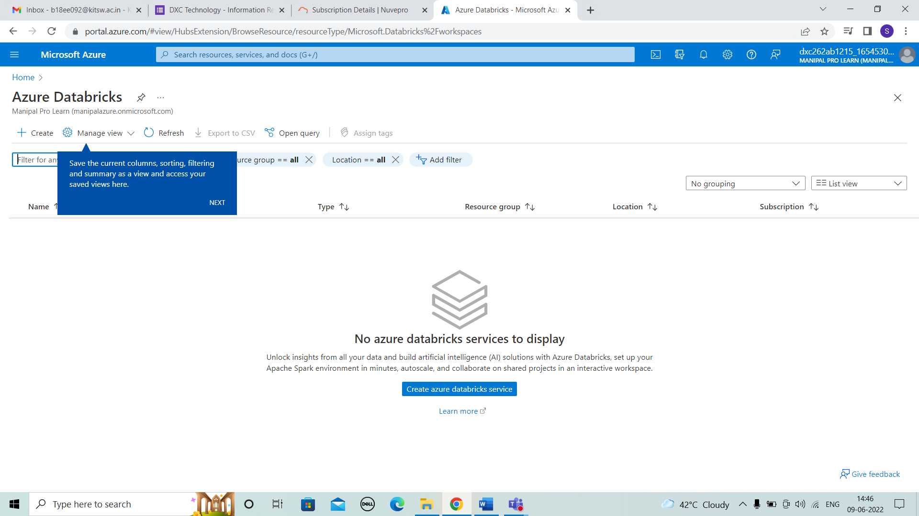



STEP 3:For Creating data bricks enter the details of resource group , workspace name and pricing tier as shown.

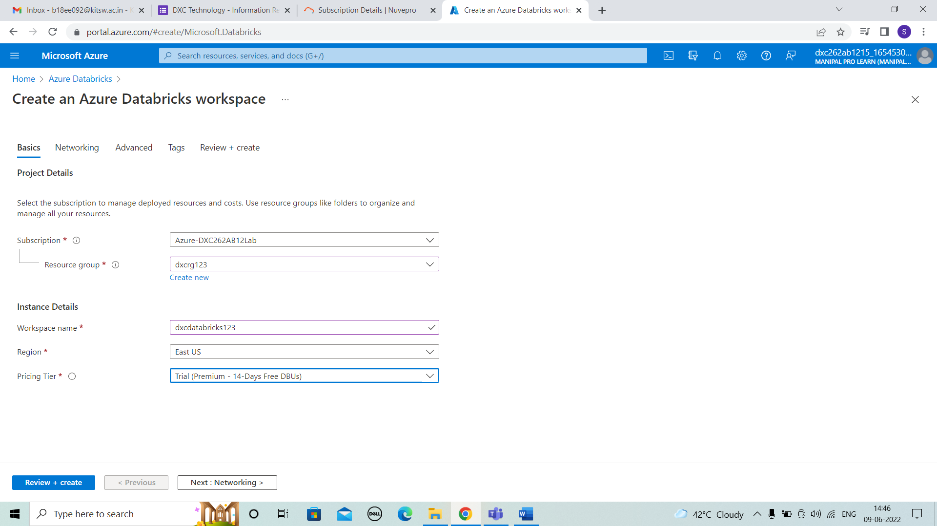



STEP 4: After details review and create. Then click on create.

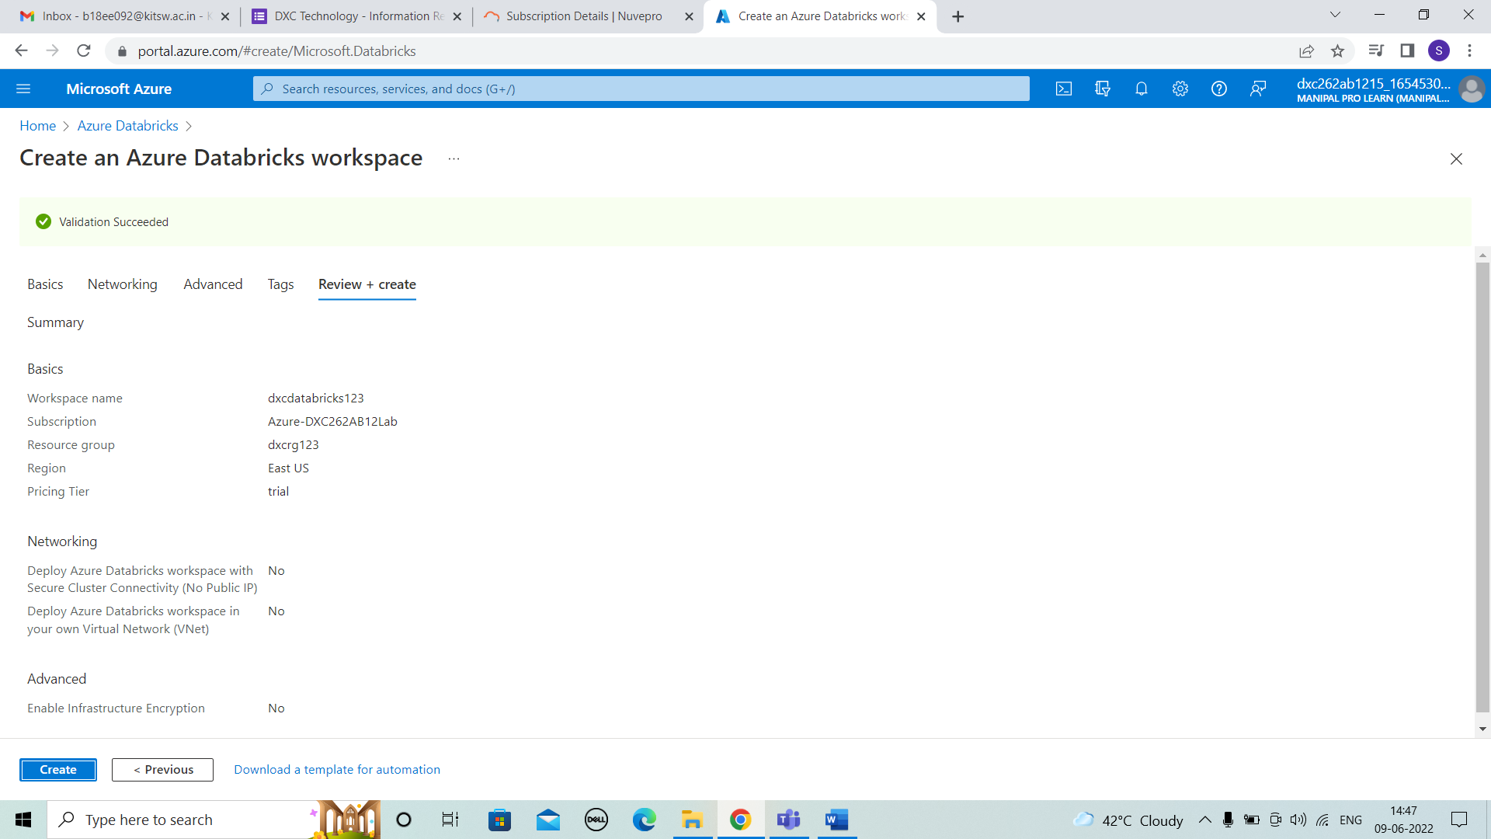



STEP 5: After create the deployment is in progress.

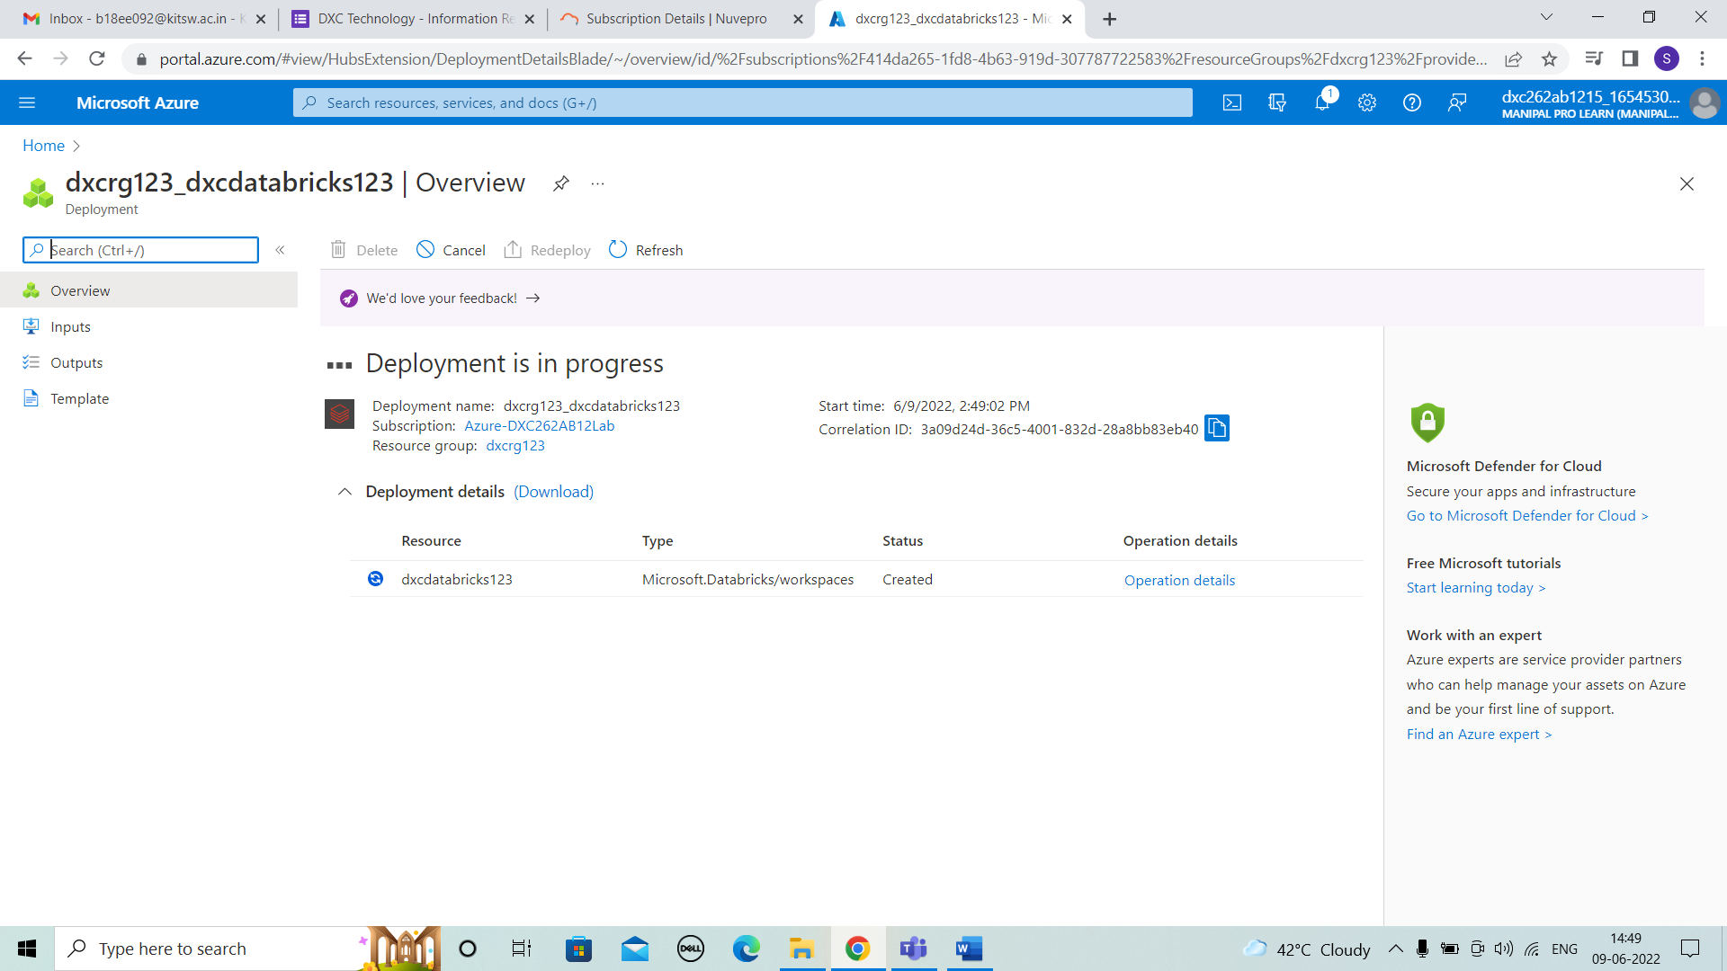



STEP 6: After the progress the deployment is completed and succeeded.

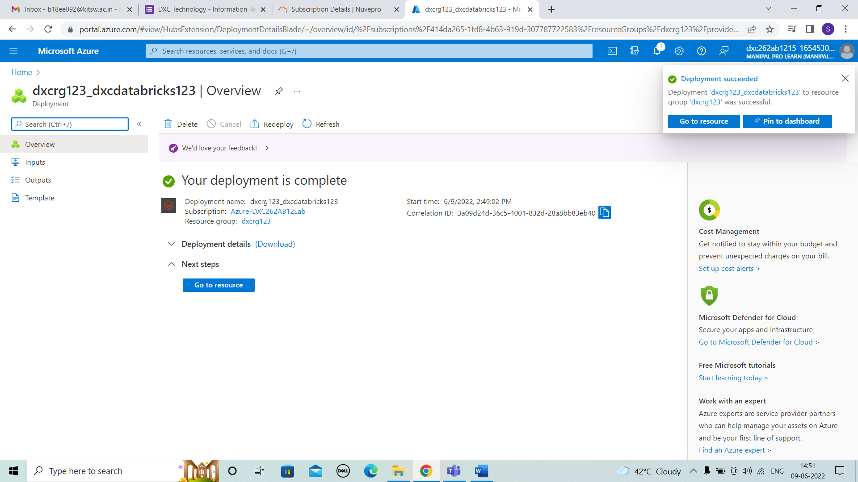



STEP 7: The data bricks page is displayed and we have to launch workspace.

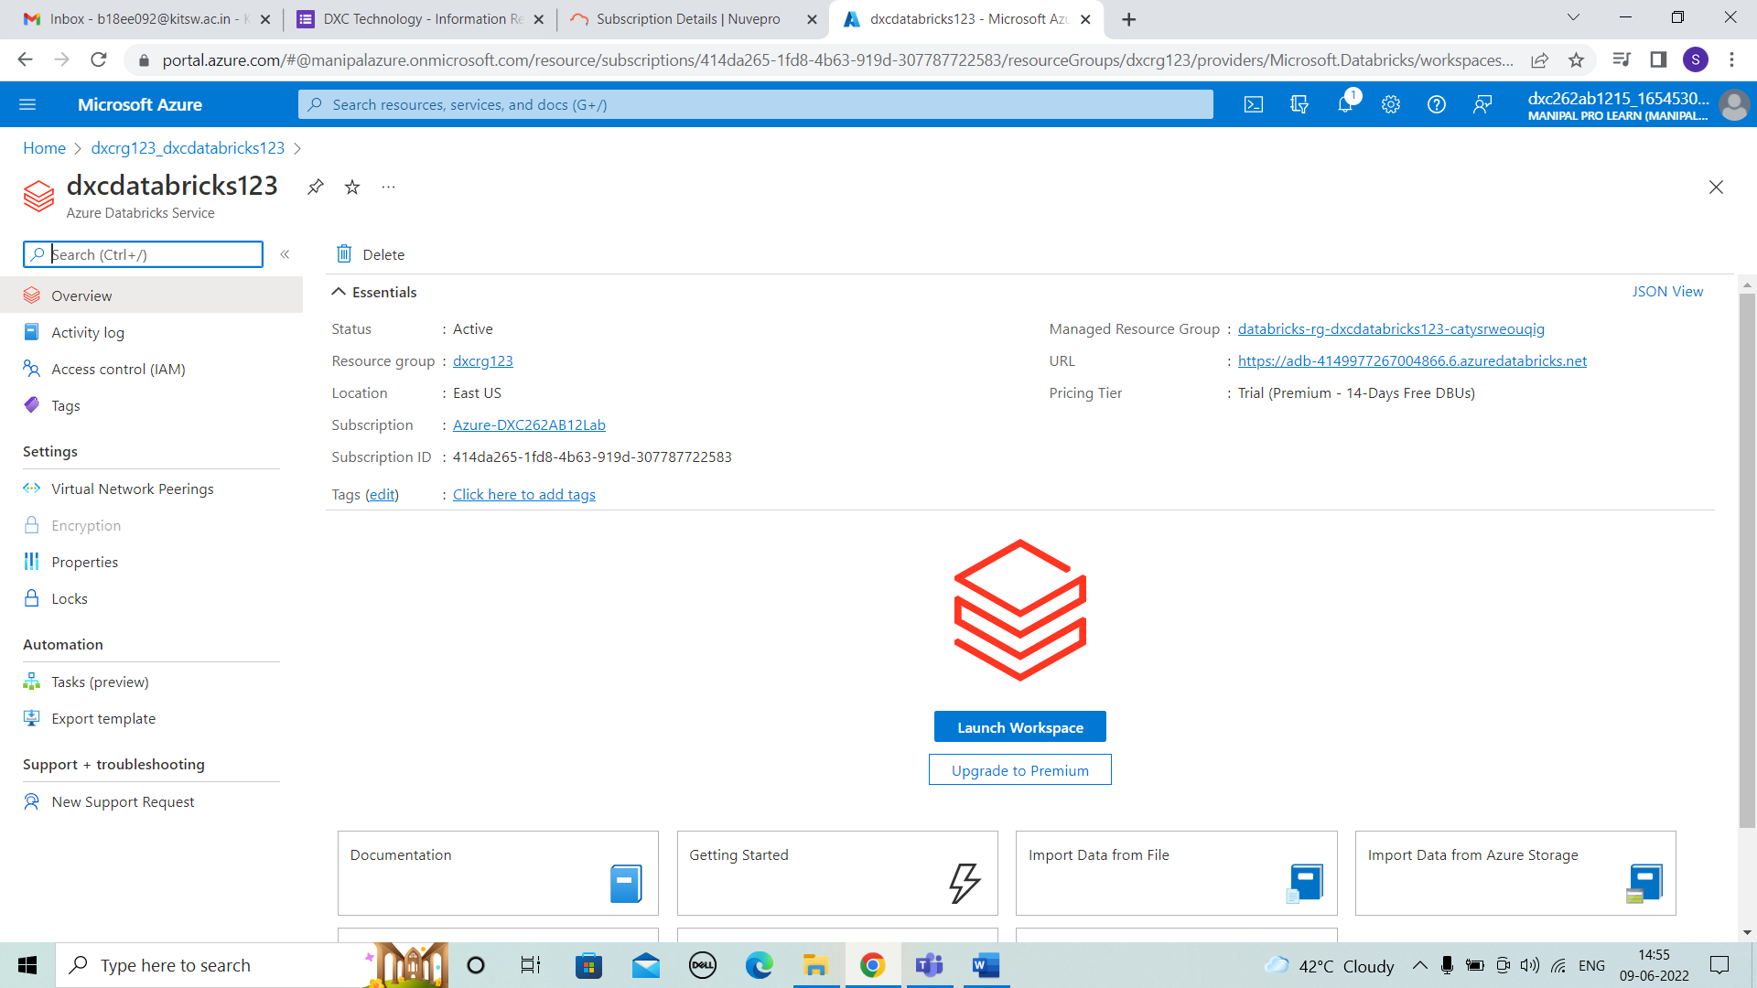



STEP 8: The Databrick page displayed for creating and workspace and other will be shown.

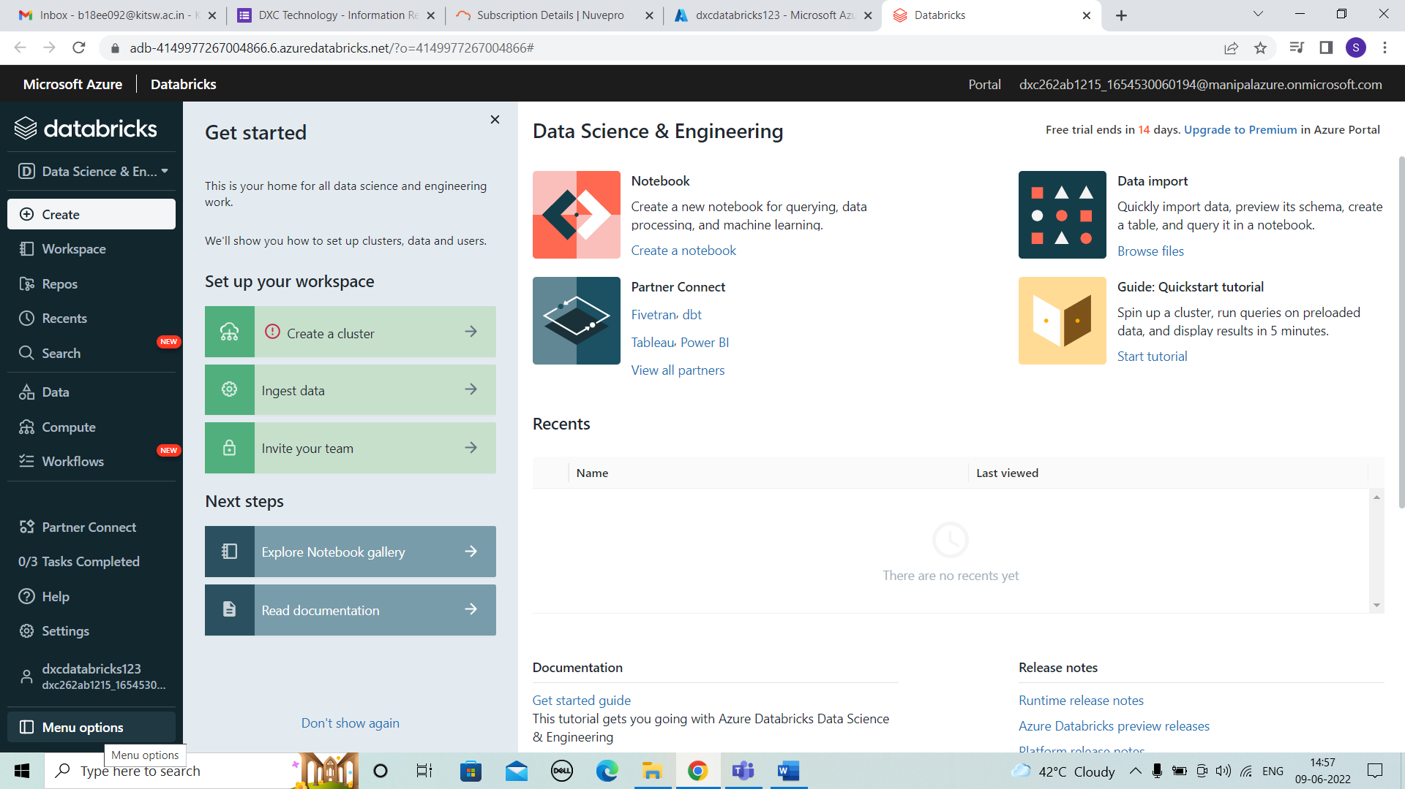



9. Explain the steps with screenshots how to create notebooks in Databricks ?

SOLUTION :

STEP 1:For creating notebooks we have to select workspace and right click>create>notebook.

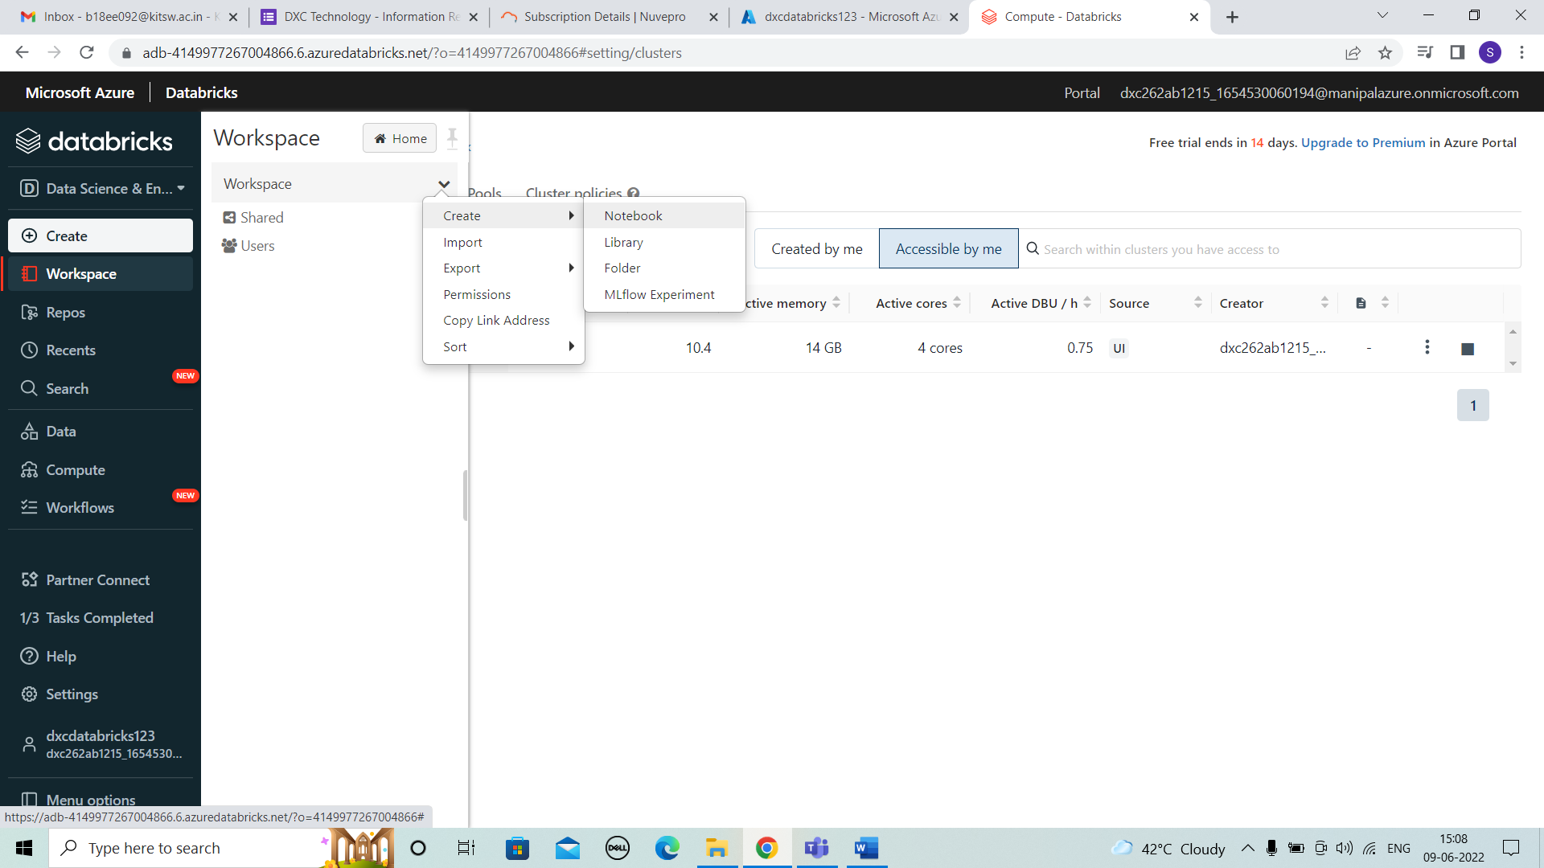

STEP 2: For creating notebook we have to give the details of name

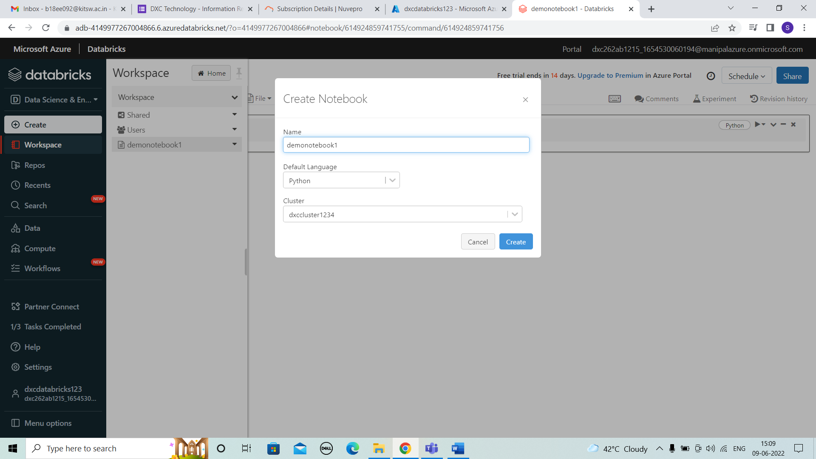

STEP 3:After creating the notebook we can enter the any details and run it.

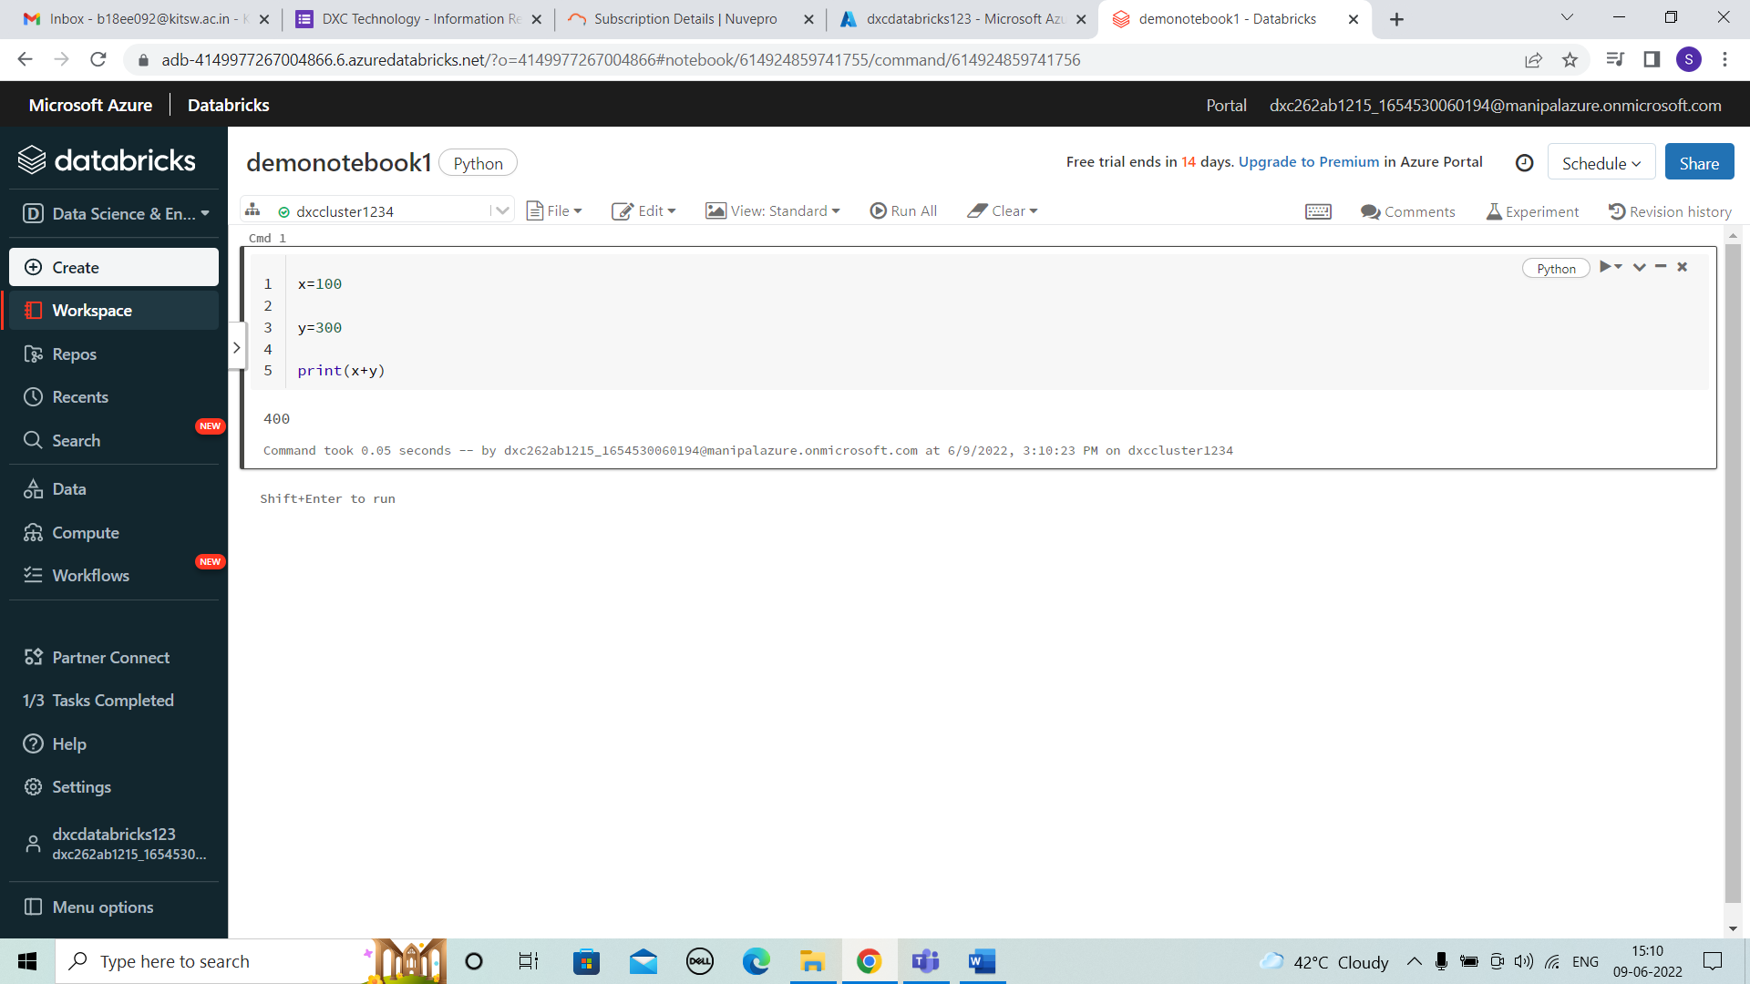

10. Explain the steps with screenshots how to insert data into data bricks notebook & display the result?

SOLUTION :

STEP 1: For inserting data into data bricks create new table by “create” and upload file.

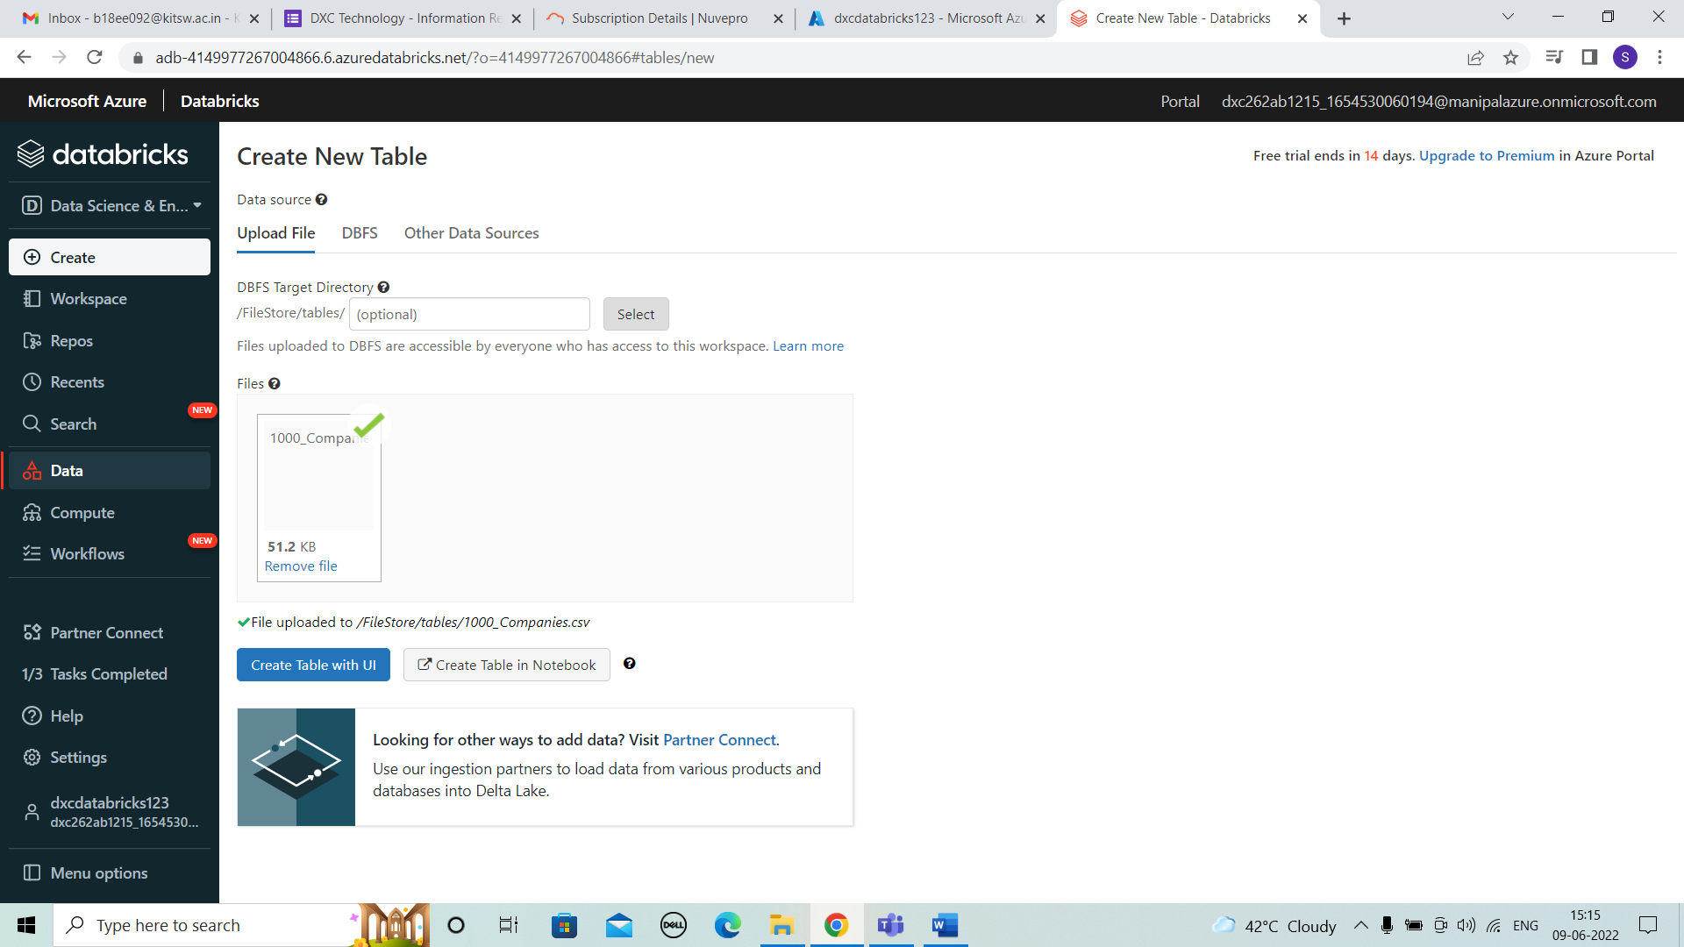

STEP 2: After uploading file create table in notebook is choosed and we can see overview.

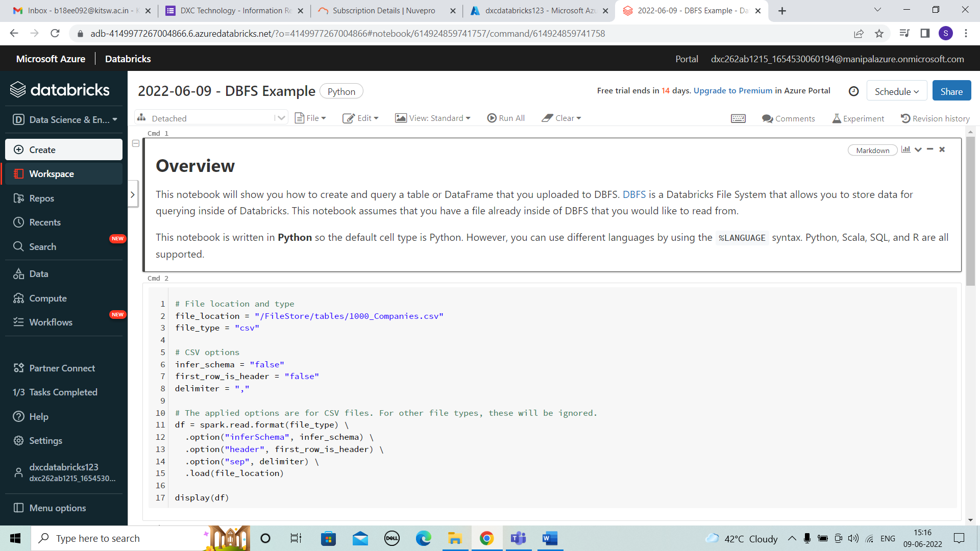



STEP 3: Name of the file should not start with numbers or spaces so correct all the file names in the code in same way.

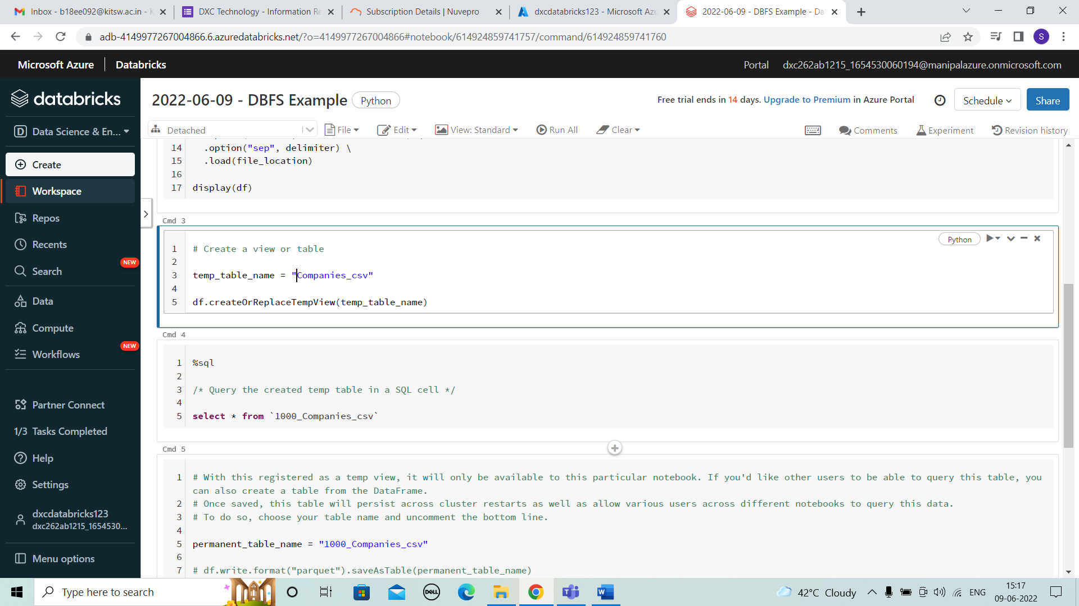



STEP 4: All the names are changes and cluster should be selected .

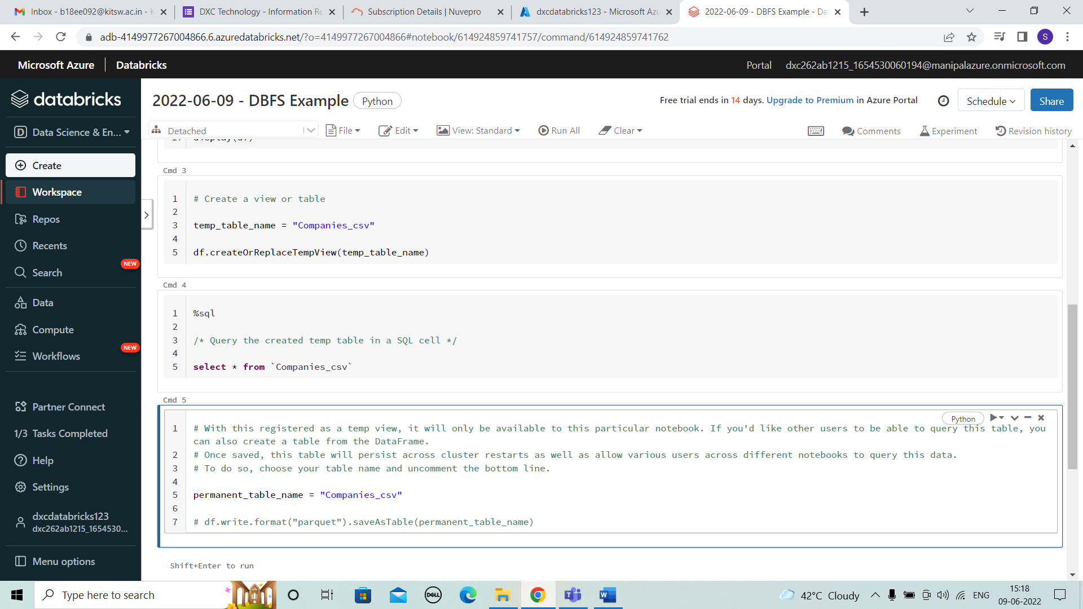



STEP 5: after all the corrections we have to run . then the table is displayed.

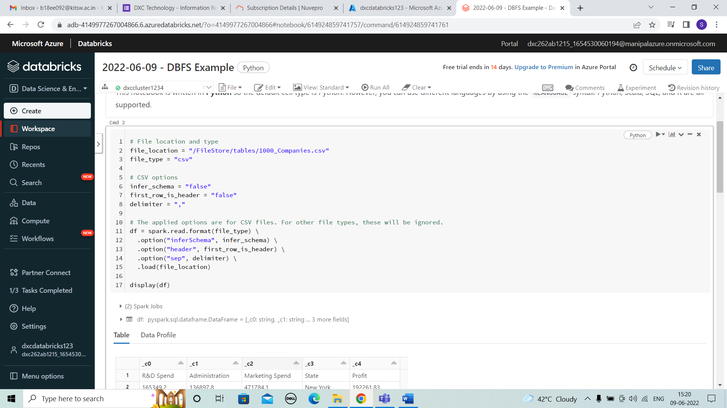



11. Explain the steps with screenshots how to create cluster in data bricks ?

SOLUTION :

STEP 1: For creating the cluster choose data science & engineering .

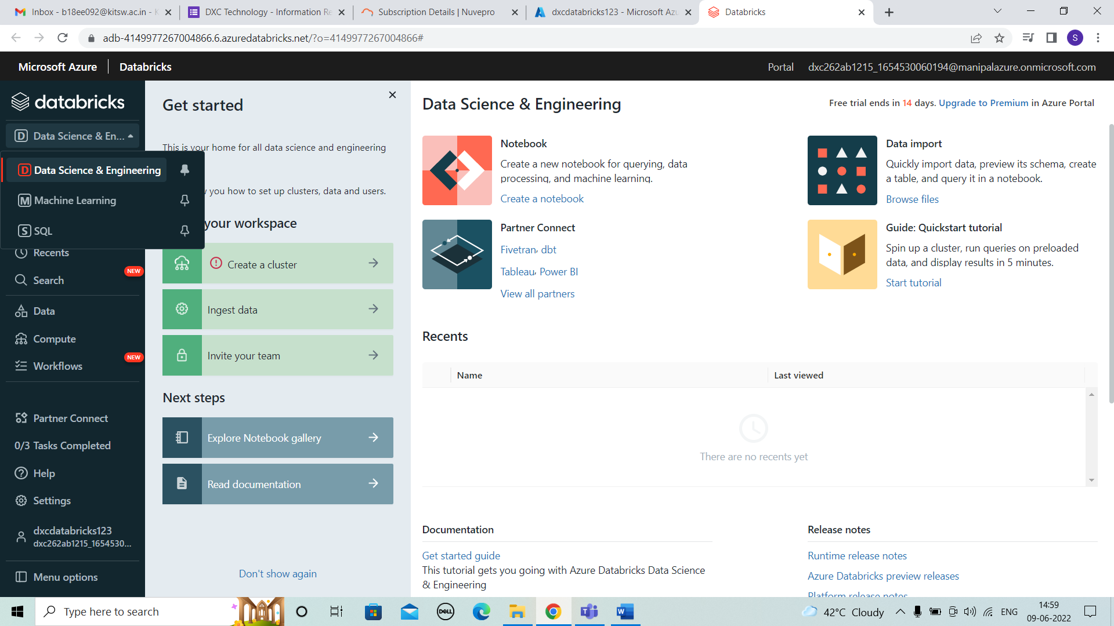



STEP 2:In compute we can see create cluster. Click on it

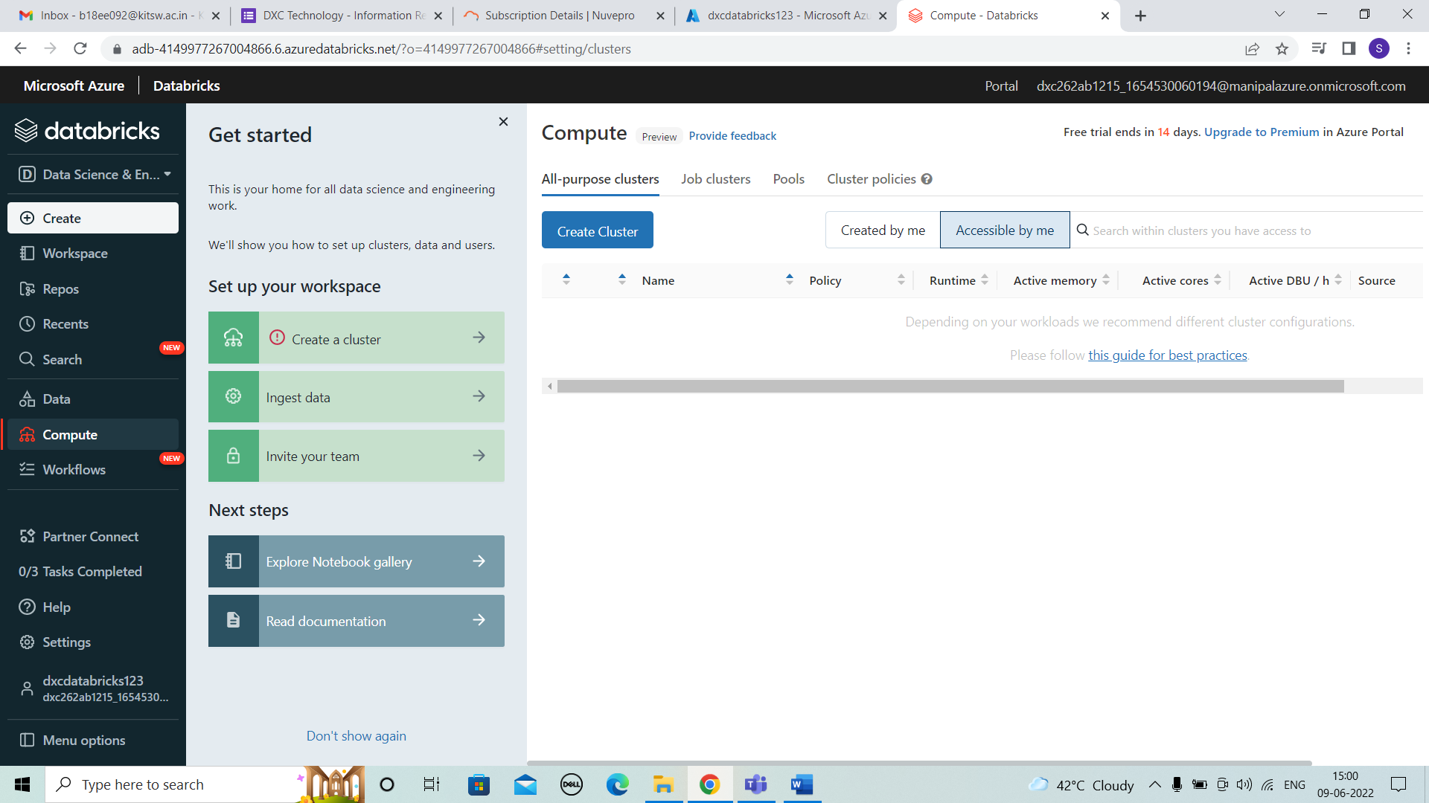



STEP 3: For creating cluster fill the details of cluster name,mode,version as shown below.

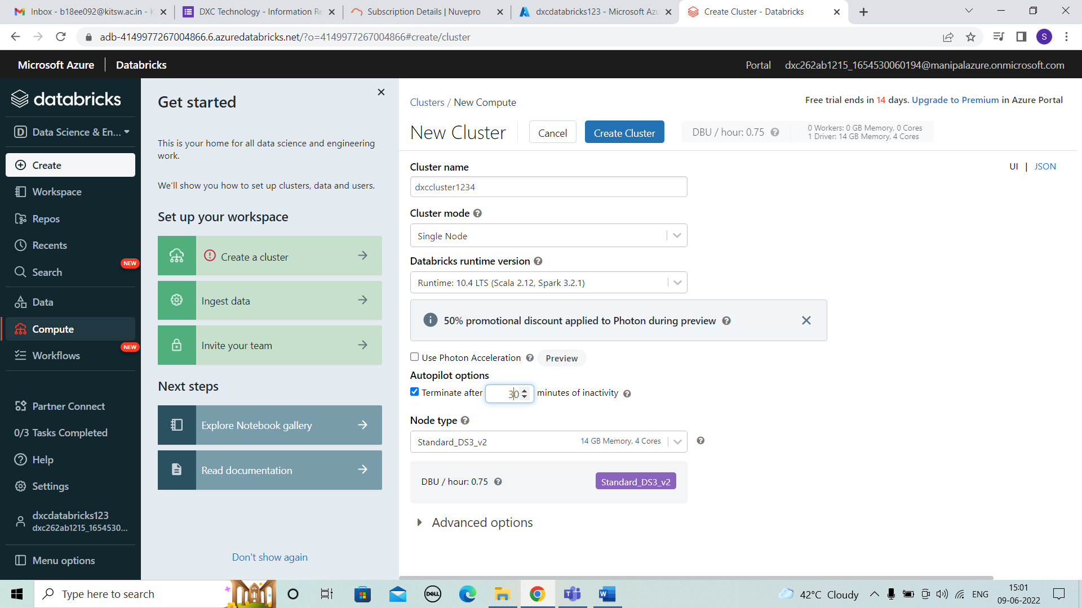



STEP 4: The cluster will be in process creating.

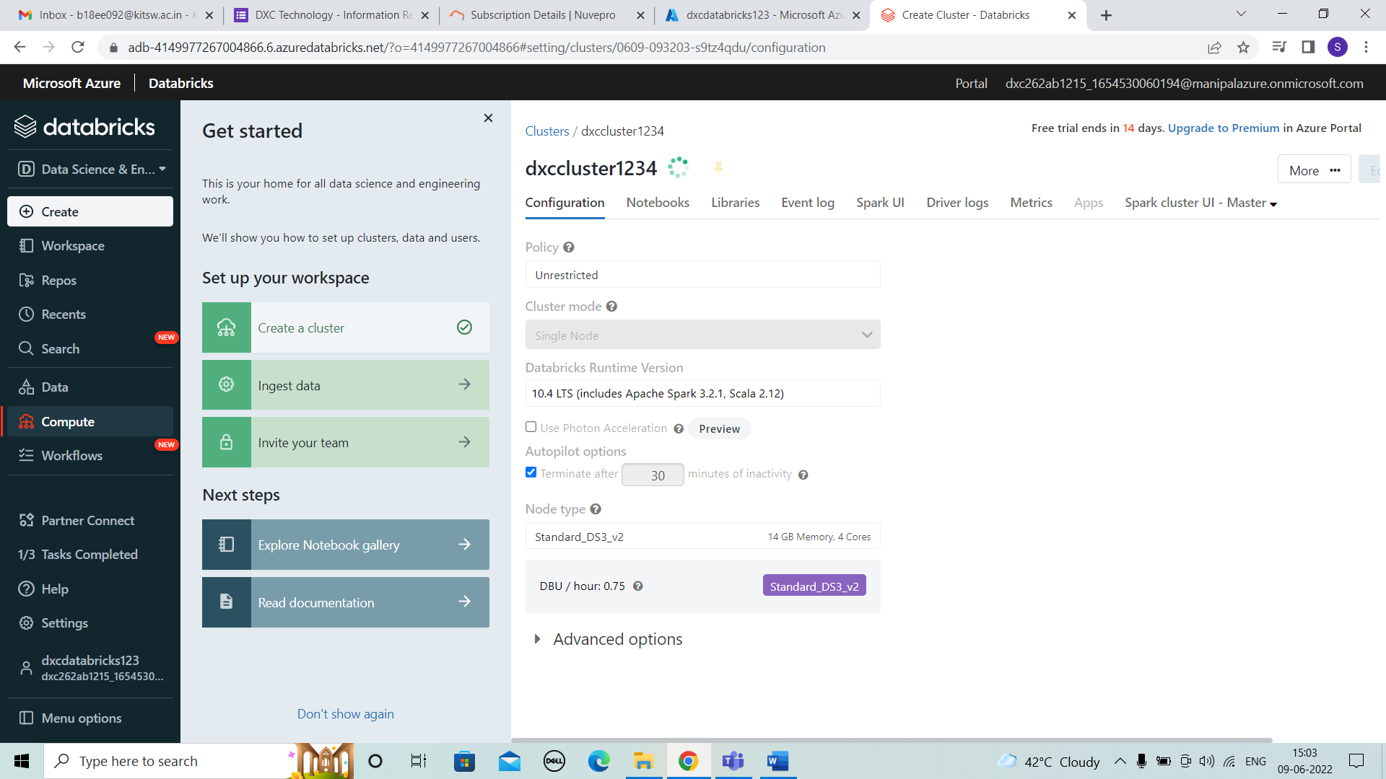



STEP 5: The cluster is created .

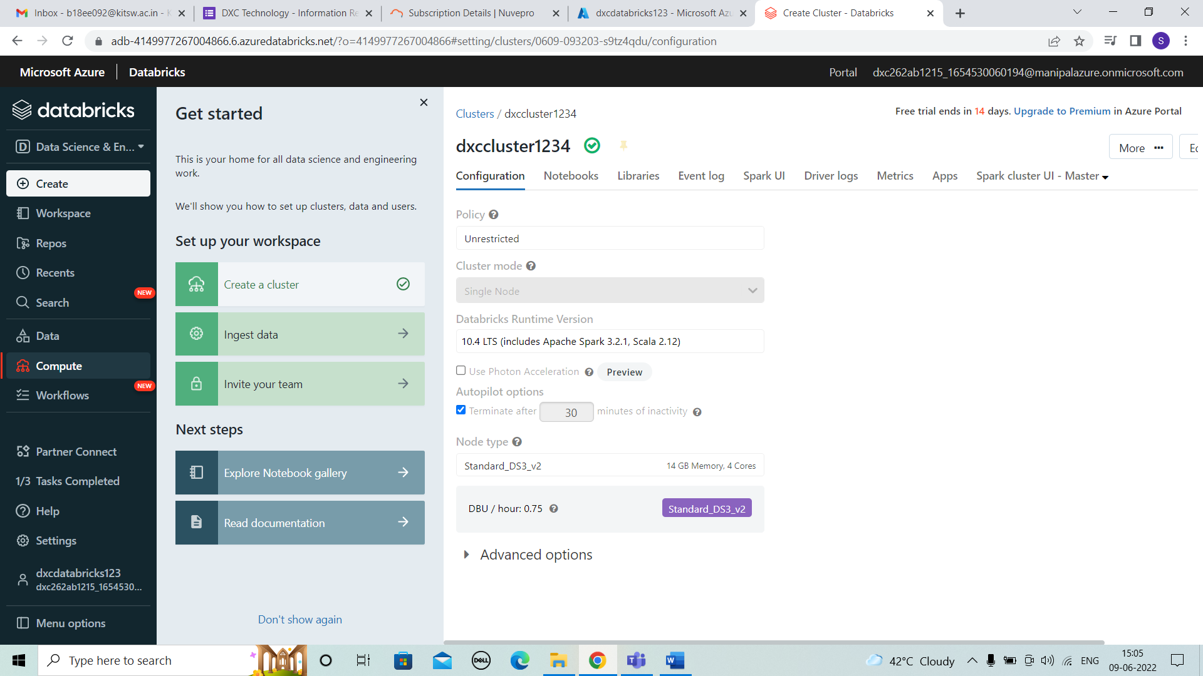



STEP 6: Now the cluster can be seen as shown below.

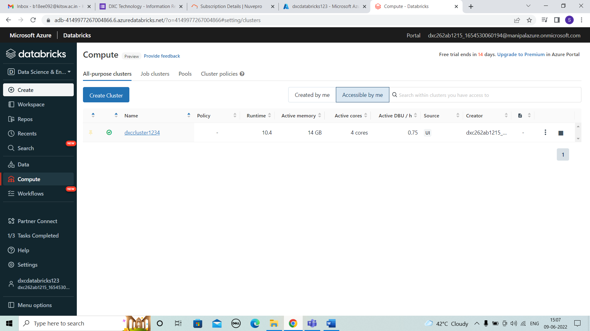

RESULTS:

I HAVE SUCCESSFULLY ANSWERED ALL THE QUESTIONS AS PER ASSIGNMENT REQUIREMENT.

CONCLUSIONS:

All the questions have been solved successfully with all the concepts that have been covered in the training session. It’s really a great experience of learning while solving the cases. This assignment gave me immense confidence regarding my ability to upskill in new technologies.